Mountain skies by Leslie Young
Last month we took an intellectual journey through six thousand years. This month we'll just look at the stars.
We start the same way we started last month: find the curved handle of the Big Dipper, and "follow the arc to Arcturus." Arcturus is a bright red star, the fourth brightest star in the sky.
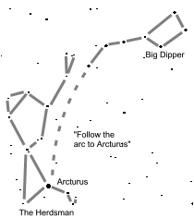

Arcturus is the brightest star in the constellation Boötes, the Herdsman. And what does he herd? As we all do when unwelcome company visits our trash, Boötes herds the big bear, Ursa Major. Arcturus is Greek for "bear keeper." (The Big Dipper is part of the constellation Ursa Major, but more about that some other month).
Seeing figures in the stars is a game of "connect the dots," and most books connect the stars in the Herdsman so it looks like an odd-shaped kite. The pattern of lines I drew here comes from my favorite guides to the constellations: Find the Constellations and The Stars, both by H. A. Rey. This is also the illustrator of the Curious George books, so you'll usually find them in the children's section.
In this drawing, the Herdsman is taking a rest (as you would too, herding bear). He's sitting down, facing right. Arcturus marks the hip of his triangular body. His large head is in profile, with a little triangular cap, and he's smoking a refreshing pipe.

