Chris, Geoff and others: make sure the final printed version has apostrophes (they’re lost in my version) and that Rick’s equations print OK.

Development of an SwRI Mars Atmosphere Model

Principal Investigator: Geoff Crowley (15)

Co-Investigators:

Christopher J. Freitas (18), Mark Bullock (15), Leslie Young (15), Walter Huebner (15), Dan Boice (15), Randy Gladstone (15), David Grinspoon (15), Richard Link (15).

External Unfunded Collaborators:

Steve Bougher (U.Arizona) - Mars upper atmosphere

Steven Clifford (LPI, Houston) - Mars hydrology, volatiles

James Brad Dalton (NASA-Ames) - Mars balloon missions

1. Introduction
The exploration of Mars is currently the centerpiece of NASA planetary research. This has been driven in recent times by the possibility that this planet was once more Earth-like than it is today. This possibility raises questions as to what processes and forces have modified the Martian environment and created the planet we observe today. In addition, the possibility of biological life on Mars, at sometime in its history, based on fossil records in meteorites has also spurred plans for significant planetary missions to Mars and the funding of supporting scientific research. The early exploration phase of Mars is somewhat complete, and over the short term (of a few years) a focus will be on the detailed interpretation of existing data and its use in the performance of modeling activities to support scientific understanding. These activities will be necessary and essential to support the design of future missions to Mars.
There are two primary questions that scientists wish to answer in the context of Mars. First, what processes and forces shaped the development of the present-day atmosphere and resulted in the presumed loss of water? And, second, did biological life develop on Mars? In this proposed effort, we plan on initiating the development of a computational tool, a General Circulation Model (GCM), which will support research designed to answer the first question. The second question is presently outside the scope of this effort; however, the GCM code proposed here, may some day be used in support of missions that address this second question.
There are several key issues that are not addressed by existing models of the Martian atmosphere, and thus modeling of the Mars atmosphere remains a rich subject for investigation and funding. Of major interest to NASA, from the scientific context, are understanding diurnal, seasonal and epoch water exchange and volatile loss throughout Martian history. Volatile loss is a cornerstone of a number of important science questions because it must be understood to help explain the current atmospheric state and the apparent lack of water on the planet. A complete GCM model including volatile loss processes will require explicit ground interaction, with varying composition such as upward fluxes of H₂O that are required for a study of hydrogen (a photodissociation product of water) chemistry in the upper atmosphere. The volatile loss problem also requires a GCM model to include the thermosphere and ionosphere, in order to obtain better background information on the O/H corona around Mars. Including these regions in a Mars GCM allows for the estimation of escape fluxes for the present time, which can then be extrapolated backward in time to post-cast the atmospheric state at significantly earlier time periods.
There are several existing three-dimensional GCM codes, but they have tended to be focused on the description of different, discrete layers of the Mars atmosphere. These models are:
- NCAR/UArizona model – this model describes the Mars ionosphere and thermosphere, which extend from 70-300 km altitudes. It specifically excludes any dust interactions, which are assumed to be less important above 50 km. It has been used to predict aerobraking maneuvers for NASA’s Mars Global Surveyor and other missions (Bougher, private communication, December 2001).
- NASA/Ames model – this model extends from the ground to 120 km, and includes the effects of varying topography, albedo and convective adjustment. There is an effort underway at NCAR to couple the AMES and NCAR/UArizona models. In it current state, the coupled model passes information upward, but not downward. In addition, there are difficulties in the model coupling procedure due to the fact that the winds near 70 km, at the boundary between the models, are non-zero. Further, the crossover level from local thermodynamic equilibrium (LTE) to non-LTE occurs near 80 km, which has make the artificial boundary condition specification at the model’s interface to be difficult to formulate.
- French model - this model extends from the ground surface to 120 km and has similar capabilities to the NASA/Ames model.
- British model – this model appears to have lost favor and its development has languished.
As demonstrated above, no existing GCM model resolves the physics of the Martian atmosphere from the ground surface through the ionosphere in a single set of equations and boundary conditions. The NCAR/Ames coupled model attempts to resolve this region (ground surface through ionosphere), but may be limited in application due to the artificial boundary condition that must be applied at the interface between the models. We believe that there is a need for an alternative approach to the development of a Mars GCM. It is proposed here to begin the development of such a Mars GCM. One that is capable of directly modeling ground surface processes, escape flux processes at the top of the atmosphere, and all intervening processes that occur in the region bounded by these two extremes of ground plane and top of the atmosphere.
The new model proposed for development at SwRI will be based on the SwRI Advanced SPace ENvironment (ASPEN) model of the Earth’s middle and upper atmosphere. The ASPEN code was developed by Crowley and Freitas (2002) under IR projects (15-XXXXX and 15-XXXXX) and with external funding. This is a fully parallelized model running on the Div 18/15 Beowulf system. ASPEN solves the momentum and thermodynamic equations to predict temperature and wind fields from 10.0 mb to 0.01 mb pressure levels. On the Earth, these pressures correspond to an altitude range of 30 km to 500 km, CHECK THIS UPPER ALTITUDE -- RECTIFY WITH PRESSURE OF UPPER BOUNDARY while for Mars, these pressure levels would include the entire Martian atmosphere. The model includes major and minor composition modules, and solves for radiative transfer and a fully coupled ionosphere-thermosphere with electrodynamics.
Figure 1 displays the complete vision of the project team for the development of this new Mars GCM. As stated, this Mars GCM will be based on the ASPEN model of Earth's atmosphere, developed at SwRI by PI Crowley and Co-I Freitas (see Section 2.1), The Mars model will include ionospheric chemistry, using the Mars ionosphere model developed at SwRI by Co-I Rick Link (see Section 2.5); radiative transfer, including scattering by gases and aerosols, using code developed at SwRI by Co-Is Bullock and Grinspoon (see Section 2.3); transport of mass, energy, and momentum through the planetary boundary layer, including interaction with volatile surfaces, using models developed at SwRI by Co-Is Freitas, Boice, Heubner, and Young (see Section 2.2); hydrology, initially using models developed by external collaborator Clifford, but eventually incorporating models developed at SwRI in Division 20 (see Section 5); and the evolution of the Deuterium to Hydrogen (D/H) ratio, using models developed at SwRI by Co-I Grinspoon (see Section 2.4).

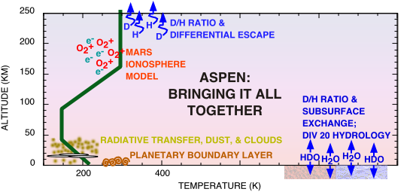
Figure 1. Scientific Vision (Mars's temperature as a function of altitude is shown in dark green for context).

Objectives of Proposed Program
There are four objectives in this proposed effort.
- Develop a comprehensive state-of-the-art model of the Mars atmosphere that spans the region from ground level to the top of the atmosphere that can be used for scientific studies (leading to understanding) and mission planning applications.
- Create a critical mass of expertise at SwRI in Mars atmospheric dynamics through formation of a team of planetary and atmospheric scientists/modelers
- Expand relationships with well-known Mars scientists from other institutions (in particular, Steven Bougher, Steven Clifford and Brad Dalton)
- Place SwRI in a strong position to participate in existing Mars missions, to be involved in definition of future Mars missions, and to provide both scientific expertise and mission execution expertise to NASA.
Approach of Proposed Program
The ASPEN model will be modified to represent Mars characteristics, and new modules will be developed to handle the unique Mars issues such as dust effects. Figure 1 summarizes the breadth of physics to be included in this new Mars GCM. One of the most significant changes to ASPEN required to model Mars is the inclusion of Planetary Boundary Layer (PBL) processes. THESE SENTENCES ARE REPEATED LATER. The new Mars GCM will extend from the planetary surface to altitudes of about 500km, REALLY 500 km? thus explicitly coupling the lower and upper atmospheres of Mars, thereby overcoming deficiencies of existing models. It will include the interactions between the ground and the atmosphere: specifically gas phase and dust particle exchange between the two regions, and the effect of topography. The model will thus predict volatile loss, including the effect of ground interaction. Cloud interactions will be studied using an embedded cloud model called CARMA (Community Aerosol and Radiation Model for Atmospheres). The volatile transport will be simulated over both short (daily) and geological timescales to study the water distribution and to predict the D/H ratio of the present day atmosphere, thereby helping to constrain the history of water on the planet. An embedded ionospheric module will provide improved ionospheric specifications needed to accurately simulate the D/H response. The new Mars GCM will also generate internally the tides and gravity waves that propagate into the upper atmosphere and have important consequences to vehicle manuervering (specifically aerobraking). Figure 1 also indicates the potential in the longer term (2-5 year period), where a Division 20 effort to build a hydrological model of Mars could be coupled to the Mars GCM resulting from the work proposed here. (However, we emphasize that the work proposed on the Mars GCM is not reliant on the Division 20 effort.) THIS PARAGRAPH IS LARGELY REDUNDANT WITH THE PARAGRAPH IMMEDIATELY PRECEEDING FIG. 1, BUT THAT’ OK - GIVE THE REVIEWERS LOTS OF HELP THROUGH THIS COMPLICATED PROPOSAL.
Applications for a New Mars GCM
This new Mars GCM can play a significant role in the exploration and understanding of Mars. As already discussed above, this Mars GCM may be used to gain insight and understanding to numerous scientific questions, in particular, to understanding the processes and forces that have shaped the development of the present-day atmosphere and resulted in the presumed loss of water. However, beyond this obvious application of the Mars GCM, there are two other broad categories of application that justify this proposed effort.
The first is that a Mars GCM can play a critical role in the development of and real-time assessment of flight trajectories and vehicle operations in the Martian atmosphere. In particular, application to aerocapture or aerobraking maneuvers is of current interest to NASA. Aerocapture is a procedure that uses atmospheric drag of a vehicle to slow the spacecraft sufficiently for capture by the planet’s gravity field as the vehicle passes through the outermost regions of the planet’s atmosphere. The technical challenge is to maximize vehicle drag while minimizing the effective surface area used to generate the drag force and thereby minimize heat flux to, and mass and volume of the spacecraft. In discussions by one of the Co-Is (CJF) with the Program Manager of the In-Space Propulsion Investment Area, Advanced Space Transportation Program (Dr. Gregory Garbe), he indicated that a missing link in support of the further development of aerocapature technology was predictive GCM models for Mars and other planetary atmospheres. Further, it has been reported that existing GCM models are unable to explain the large amplitude waves in the upper atmosphere measured during recent aerobraking operations completed at Mars (Bougher, private communication, December 2001).
The second application is as a cooperating model or counterpoint model, working in conjunction with the NCAR/Ames model to gain insight to Mars atmospheric dynamics. There is a distinct advantage to the community to have two models with different formulations being applied to the same problem. NOAA employs such an approach with their daily weather prediction, relying on two different production-run codes.

2. Technical Background
The proposed work is very ambitious and involves extremely diverse scientific domains and expertise. To mitigate the considerable technical risk associated with this type of endeavor, the proposed effort includes SwRI scientists who have worked or developed the techniques needed for the development of this model. Further, the project team includes three external participants with strong background in Mars science, modeling, and applications. The new model will simulate the transfer of water from the planetary regolith into the atmosphere through boundary layer processes. Dust will also be lifted from the surface and lofted into the upper atmosphere by dynamical processes. The role of the dust in the planetary heat budget will be included. Cloud formation will be simulated. The Mars ionosphere will be simulated with better chemistry than previous models. Over the long-term, the evolution of the D/H ratio will be predicted. In this section, we present some of the tools to be used and developed, together with some of the technical issues to be overcome in the proposed work. We begin with the ASPEN model because it provides the foundation on which all of the proposed work stands.
2.1 Advanced SPace ENvironment (ASPEN) Model
Atmospheric models are indispensable tools for testing our understanding of complex atmospheric systems. They can provide a framework for the interpretation of data, insight into the processes which drive observed phenomena, and can even suggest new observational modes. One of the most advanced models of the Earth’s middle and upper atmosphere is the Advanced SPace ENvironment model (ASPEN) developed at SwRI. ASPEN has its lower boundary at 10mb (~30 km) and includes the upper stratosphere and mesosphere as well as the thermosphere. It predicts winds, temperatures, major and minor composition, and electrodynamic quantities globally from 30 km to about 500 km. It does this by solving the momentum, hydrostatic, energy and continuity equations with the appropriate physics and chemistry for each altitude.
The 3D model is formulated in the corotating geographic frame with a horizontal grid resolution of ~500 km (5deg latitude by 5 deg longitude), and a vertical resolution of 0.25 pressure scale heights. The Eulerian nature of the model makes it natural to develop a solution for the entire 3D grid at every time step. The model is typically run with a 3-minute time step. The regular Eulerian grid simplifies the parallelization of the code.
ASPEN is based on the same physics and chemistry as the well-known Thermosphere Ionosphere Mesosphere Electrodynamics General Circulation Model (TIMEGCM), which was developed at the National Center for Atmospheric Research (NCAR). The TIMEGCM was described by Roble and Ridley (1994), and is the latest in a series of 3-D models developed at NCAR. ASPEN extends the performance of the TIMEGCM by the use of a different gridding scheme, and a different structure for passing information between grid points in the model (Crowley and Freitas, 2000; Freitas and Crowley, 1999). ASPEN runs on UNIX and Linux systems such as the SwRI Beowulf Computing Facility.
The model currently solves for the neutral, electron and ion temperature profiles as well as for the compositional profiles of O_{X} = (O + O₃), O₂, and N₂ coupled through major species diffusion equations. It also includes as minor species with transport and appropriate photochemistry: N(⁴S), NO_{X} = (NO + NO₂), H₂O, H₂, CH₄, CO, CO₂, and HO_{x} = (H + OH + HO₂). The model also includes appropriate F-, E- and D-region ion chemistry.
The mesospheric chemistry is essentially the same as that described by Allen et al. (1984) and Brasseur and Solomon (1986) using the JPL-90 reaction and photoabsorption rates (DeMore et al., 1990). However, rates are updated as they are revised. Even though the model was extended into the upper stratosphere (to resolve the stratopause) the stratospheric chemistry was limited and excluded species such as Clx, N₂O, NO3, N₂O₅, etc. It was assumed that the effect of these species could be accounted for by specifying lower boundary mixing ratios obtained from a more complete chemical/dynamic model of the stratosphere. Typically, the long-lived species at the lower boundary are obtained from the 2-D chemical/dynamic model of Brasseur et al. (1990).
The inputs required by ASPEN include the solar flux at 57 key wavelengths, auroral particle precipitation, high latitude electric fields, and tides propagating up from below the 10mb lower boundary. A gravity wave drag parameterization specifies the momentum deposition, heating and turbulent mixing associated with gravity waves interacting with the general circulation. This parameterization allows the model to simulate both the mean circulation and tides in the upper mesosphere for equinox and solstice conditions (Roble et al., 1997; Crowley et al., 2002).
Dr. Crowley has interacted with the NCAR developers of TIMEGCM for over 15 years and has published over 20 papers using the NCAR models (e.g. Crowley et al., 1989a, b). Validation of the middle atmosphere portion of ASPEN and the TIMEGCM has progressed by study of various parameters. For example, Dr. Crowley led the modeling effort in the mesospheric nightglow investigations of Yee et al. (1997). We are now using ASPEN to investigate the mesospheric thermal structure and energetics (Crowley et al., 2002), and the effects of particles on the middle atmosphere (Frahm et al., 1997; Crowley et al., 1998, 1999; Ridley et al., 1999; Sharber et al., 2000).
The development of ASPEN at SwRI for studies of the Earth’s atmosphere has been very successful. It has resulted in significant new research results, and has brought over $2 Million of external funding to SwRI over the last 5 years from agencies as diverse as NASA, NSF and the DoD. We anticipate that the same success in attracting external funding, and opening the way to mission involvement, will result from the development of the Mars GCM.
2.2 Simulation of the Martian Boundary Layer and Surface Environment
Planetary Boundary Layer (PBL) processes are essential to the dynamics of the lower atmosphere of any solid body with a sufficiently dense atmospheric mixture. It is at the ground surface where the fluid atmosphere interfaces to important sources and repositories of energy (thermal, thermodynamic, and viscous) and mass (chemical species and particles). PBL processes are driven by momentum, thermal, radiative, and concentration gradients. Fluid flow at this interface is essential to the transport of chemical species, vapor, and dust particles.
On Mars, the PBL occupies the lowest few kilometers of the atmosphere, and comprises a significant fraction of the mass of the atmosphere. The PBL is characterized by a large change in temperatures from day to night, with convective mixing during the day, and a stable inversion layer with a very large temperature gradient at night. The fluxes of heat, mass, and momentum in the PBL are important drivers for the rest of the atmosphere, and the determination of these fluxes is one of the chief goals of PBL modeling (e.g., Haberle et al. 1993; Savijaervi 1995). PBL modeling can also shed light on the processes that exchange volatiles, such as CO₂ and H₂O, across the surface-atmosphere interface. The conditions under which dust can be raised from the surface and then transported is another important area of research that requires detailed knowledge of PBL processes.
PBL and the bulk CO₂ atmosphere
The dominant atmospheric constituent on Mars, CO₂, is also present as frost at the poles of this planet. The pressures and temperatures at the surface of Mars is at the CO₂ triple point, so the atmosphere and surface are in a dynamic equilibrium; the surface pressure on Mars is controlled by the equilibrium vapor-pressure of CO₂. Because equilibrium vapor pressure is an extremely sensitive function of temperature, the surface pressure reacts dramatically to changes in the temperature of the volatile frost. As the Martian surface warms up during its season, the CO₂ frosts sublimate, adding mass to the bulk atmosphere. On Mars, this has a significant global effect, altering the surface pressure by ~30% on an annual cycle.
Through the latent heat of sublimation, the surface-atmosphere exchange of CO₂ is critical for transporting energy between the surface and atmosphere and between different areas on Mars’s surface. As described by Leighton and Murray (1966), the mass and energy balance must include all volatile deposits, as well as the atmosphere. On Mars, there are times when CO₂ is present only at the winter pole (especially during Northern summer/fall, when the CO₂ has sublimed from the Northern polar cap). In this case, the energy imbalance on the winter pole is made up for by condensation, and the mass of the atmosphere (and therefore the surface pressure) drops (see Figure 2). When both poles have CO₂, they both participate in the energy/mass balance (Figure 3).

NEW FIGURE 2 (SMALL CHANGE TO “LATENT HEAT” LABEL)
Figure 2. Single-pole energy balance between thermal radiation, latent heat of sublimation, and conduction from the subsurface (not shown). Solar heating is zero for the winter pole at solstice. The frozen CO₂ (blue) at the winter pole exchanges mass with the atmosphere. The regions clear of CO₂ (red), including the summer pole, do not participate in the CO₂ cycle.

NEW FIGURE 3 (SMALL CHANGE TO “LATENT HEAT” LABEL)
Figure 3. Dual-pole energy balance between thermal radiation, latent heat of sublimation, solar heating, and conduction from the subsurface (not shown). Solar heating is greater at the summer pole than at the winter pole. The poles are at nearly the same temperature. Transport of frost from the summer to the winter pole also transports latent heat of sublimation. When the surface pressure is increasing, there is a net loss of latent heat from the sum of both poles. The transport of latent heat from summer to winter pole helps cancel the imbalance in solar energy, so the temperatures and equilibrium vapor-pressures of the poles are similar.

MOVE TO TEAM CAPABILITY SECTION, OR ADD A SIMILAR SHORT PARAGRAPH TO THE OTHER SECTIONS.

The Martian atmosphere that is in contact with CO₂ frost will stick to the surface at a rate that is proportional to the sticking coefficient, the mean molecular speed of the gas, the inverse of the surface temperature, and the surface pressure. Similarly, the sublimation rate over CO₂ frost is proportional to the sticking coefficient, the mean molecular speed of the gas, the inverse of the surface temperature, and the equilibrium vapor pressure at the surface temperature. When the surface pressure equals the equilibrium vapor pressure, there is no net change to the atmospheric column density of CO₂. However, the continuous exchange of CO₂ molecules between the surface and atmosphere can have an effect on the microphysical state of the surface, such as grain size. This can effect emissivity, and albedo, which in turn affect the energy balance of the surface-atmosphere system; higher albedo decreases the absorbed sunlight, while higher emissivity increases the energy lost by thermal radiation.
PBL and the water cycle
Near-surface water (both in the regolith and atmosphere) represents a potentially important resource for the exploration of Mars. However, most analyses of these resources (cf. Mellon and Jakosky, 1993, and references therein) hearken back to the seminal discussion of Martian volatiles by Leighton and Murray (1966) that assumed a planet wide average water vapor column of about 10 precipitable micrometers. This ignores considerable latitude, seasonal, and diurnal variations in water vapor. Similarly, previous high-resolution boundary layer modeling of the diurnal water cycle regarded the atmospheric column as controlling the soil conditions. Thus, the soil was initialized with some 2 kg m⁻³ (corresponding to 20 precipitable micrometers) of water, causing the assumed atmospheric column to be filled in a matter of days. Global modeling of the Martian water cycle over a period of several decades, on the other hand, gives strong indications that the regolith water inventory is much smaller and that adsorption of water on this regolith dominates the lower atmospheric column. Houben (1999) calculated diurnal boundary-layer conditions using a one-dimensional model (Zent et al. 1993) but which was initialized with a smaller estimated soil water inventories (Houben et al. 1997) for a variety of locations and seasons on Mars.
The near-surface nighttime atmospheric water vapor concentrations were inferred by Ryan et al. (1992) from Viking Lander air temperature measurements. They are lower by a factor of 2-3 than the same quantities estimated from daytime atmospheric column water vapor abundances observed from the Viking Orbiters. Jakosky et al. (1997) show that a physical model of the atmospheric boundary layer and regolith can produce a nighttime depletion of this magnitude by diffusion of water into the regolith and adsorption onto regolith grains. Quantitative validation of their model is not possible at present due to the lack of direct measurements of the near-surface atmospheric water vapor concentration and by uncertainties regarding surface regolith and atmospheric boundary layer properties. However, if the diurnal exchange of water vapor with the surface is as large as is suggested by the Viking Lander and Orbiter measurements, then they conclude that the exchange of water between the atmosphere and regolith also is important in the seasonal cycle of water vapor. Further characterization of these processes can be made using measurements from the various landing site and atmospheric profiling experiments conducted by the Mars Pathfinder and Mars Global Surveyor missions.
Zent et al. (1993) have a one-dimensional numerical model of the exchange of H₂O between the atmosphere and subsurface of Mars through the planetary boundary layer (PBL), in which they explore the mechanisms of H₂O exchange and elucidate the role played by the regolith in the local H₂O budget. Their atmospheric model includes effects of Coriolis, pressure gradient, and frictional forces for momentum: radiation, sensible heat flux, and advection for heat. The model differs from Flasar and Goody (1976) by use of appropriate Viking-based physical constants and inclusion of the radiative effects of atmospheric dust. The pressure gradient force is specified or computed from a simple slope model. The subsurface model accounts for conduction of heat and diffusion of H₂O through a porous adsorbing medium in response to diurnal forcing. TOO MUCH DETAIL. Their results suggest that in most cases, the flux through the Martian surface reverses twice in the course of each sol. In the midmorning, the regolith begins to release H₂O to the atmosphere and continues to do so until midafternoon, when it once more becomes a sink. It remains an H₂O sink throughout the Martian night. In the early morning and late afternoon, while the atmosphere is convective, the atmosphere supplies H₂O to the ground at a rapid rate, occasionally resulting in strong pulses of H₂O into the ground. The model also predicts that for typical conditions, perhaps 15–20 sols are required for the regolith to supply an initially dry atmosphere with its equilibrium load. The effects of surface albedo, thermal inertia, solar declination, atmospheric optical depth, and regolith pore structure have been explored within the context of the model. Albedo cools the regolith, so less H₂O appears in the atmospheric column above a bright surface. The friction velocity is higher above a dark surface, so there is more diurnal H₂O exchange; relative humidities are much higher above a bright surface. Thermal inertia affects the propagation of energy through a periodically heated homogeneous surface. The results of Zent et al. (1993) suggest that higher thermal inertia forces more H₂O into the atmosphere because the regolith is warmer at depth. Surface stresses are higher above a low surface, but there is less diurnal exchange because the atmosphere is dry. The latitude experiment predicts that the total diurnal insolation is more important to the adsorptively controlled H₂O column abundance than the peak daytime surface temperature. Fogs and high relative humidity will be far more prevalent in the winter hemisphere. The dust opacity of the atmosphere plays a very significant role; the PBL height, column abundances, relative humidity, and surface stresses all increase very strongly as the optical depth approaches zero. Their model neglected the dust opacity of the atmosphere so subsequent PLB models should incorporate this potentially important effect.
In a follow-up study, Zent et al. (2001) investigated the role of smectite clays in the Martian soil as a repository of water. Observations show diurnal variations in atmospheric water vapor. They show that it is unlikely that a significant amount of water is adsorbed in smectite clays (thought to be abundant in Martian soil) under Mars-like conditions. The reason is that the timescale for the clays to equilibrate with the surrounding water is too short when compared to a Martian soil.
In a recent press conference (March 1, 2002), initial science data from NASA’s Mars Odyssey spacecraft include possible identification of significant amounts of frozen water in the upper few feet of the Martian surface as sampled at spatial scales of approximately 400 miles. Measurements by the gamma ray spectrometer show the presence of significant amounts of hydrogen in the south polar region of Mars (southward of about 60-degrees south latitude). This stretches well beyond the south polar cap that is normally observed near the pole. The high hydrogen content is most likely due to water ice, though the amount of ice has not been quantified yet. The detection of hydrogen is based both on the intensity of gamma rays emitted by hydrogen, and by the intensity of neutrons that are moderated by hydrogen, as observed by the high energy neutron detector and the neutron spectrometer. Further analysis of these data are ongoing and will provide important constraints to the exchange between surface volatiles and the atmosphere.
IT ISN’T CLEAR WHAT WE DO WITH ZENT ET AL. I THINK WE’RE GOING TO USE THEIR RESULTS, RATHER THAN MODEL THE TRANSPORT OF WATER THROUGH THE REGOLITH, BUT THE REVIEWER HAS NO CLUE. ADD A SHORT PARAGRAPH LIKE:
We will use the results of Zent et al. and other models of H₂O transport through the regolith to establish the lower boundary for our GCM.
PBL Entrainment and Mixing
In general, the entrainment and mixing of components is a turbulent flow phenomenon in which scalar quantities (e.g., temperature, momentum, chemical species, and particles) are distributed into the bulk atmospheric flow field through complex interactions of velocity gradients.
Entrainment is controlled and determined by velocity gradients normal to the surface and by the local effect of molecular diffusion. The distinction between a diffusive length scale across the flow and a convective length scale along the flow is essential to the understanding of all shear flows, both laminar and turbulent. The viscous length l is a transverse length scale and represents the width (or thickness) of the viscous portion of a boundary layer, and it relates to the molecular diffusion of momentum deficit across the flow, away from the surface. Momentum deficit refers to the slowing of the fluid velocity near the solid boundary, resulting in loss of momentum with respect to the core flow. Molecular diffusion along the flow is negligible compared to the downstream transport of momentum by convection. Entrainment of discrete phases such as particles requires an understanding of the cohesive forces inhibiting particle motion (dependent on material, particle size, density, and packing characteristics), and the loss of momentum provided by the particles to the flow field resulting in deposition of particles. The entrainment factor depends on the drag coefficient. The drag coefficient for spherical dust particles as a function of Reynolds number, Re, is well established in the range 10⁻¹ < Re < 10⁶ and can be fitted easily over the range 10⁻¹ < Re < 2x10⁵ in first approximation. In addition, the accommodation factor should be taken into account for gas-dust heat transfer.
Mixing is a process that reduces the intensity of spatial gradients, be they concentration gradients, thermal gradients or velocity gradients. Mixing occurs in three different regimes or modes. The first regime is pure diffusion. In this mode, there is no characteristic velocity scale. Mixing occurs due to molecular motion of the molecules of the medium and scalar field. This process is then characterized by the diffusion coefficient of the material. The second regime is convective mixing (or advective or dispersive) which augments diffusive mixing with a characteristic velocity scale. Generally, diffusion spreads the material laterally, while convection distributes it longitudinally, stretching filaments of material along streamlines. The third regime is turbulent mixing in which vorticity supplements laminar convection and molecular diffusion. Here a spectrum of eddies stretches and twists filaments of material rapidly distributing the material throughout the region, ultimately smearing spatial gradients, and creating a homogeneous concentration field.
The atmospheric turbulence field operates on the mixing process through two mechanisms. First, the large scale eddies move and distribute large scale regions of the material. In the absence of molecular transport, turbulent mixing would carry thin sheets and filaments of material to every part of the flow field. However, there would still be large inhomogeneities at the small scales, because the filaments would be separated by regions of uncontaminated fluid. Second, with the creation of small scale inhomogeneities, local gradients in concentration augment molecular diffusion and accelerate mixing at the finest scales of the flow. For example, as a spot of concentrated material is stretched by the turbulence field in the x-direction, the concentration gradients in that direction are reduced. The rate of diffusion or mixing of a material is proportional to the concentration gradient, and thus the rate of spread in that direction is reduced. In the y-direction, however, the filament region is being compressed so that concentration gradients and the rate of molecular diffusion in the y-direction are increased. For small values of total strain rate, the increase in y-direction diffusion essentially balances the decrease in x-direction diffusion, thus the net increase in the mixing rate is zero. However, at large values of strain, characteristic of turbulent flows, the increase in y-direction diffusion is much larger then the decrease in x-direction diffusion, especially since the molecular diffusion coefficient provides a lower limit on the rate, while there is no real upper limit on the strain rate.
Team Capabilities
For this proposed work, existing computational tools and capabilities will be focused on the Mars PBL problem. Computational tools developed in the SwRI Computational Mechanics Section (team member CJF) to simulate turbulent entrainment and mixing in both natural and engineered systems will be leveraged for this effort. These computational tools use curvilinear coordinate systems so that terrain-following grid systems may be used to more accurately resolve the exchange of momentum, energy, and mass at solid surfaces. These computational tools use both Eulerian and Lagrangian methods to simulate fully coupled dynamics between continuum phases (gas phase and chemical species for example) and discrete phases (such as particle or droplet fields). The algorithms used in these computational tools are modular which allows for seamless enhancement and modification to the unique elements of the Mars environment.
The Mars surface boundary is thought to contain admixtures of regolith and volatiles in the ice phase, and thus this mixture state must be cast in a form for modeling the exchange of mass, momentum, energy between the boundary layer and the surface. The codes required to accomplish this task resemble the cometary codes already developed in Division 15 (e.g. ComChem, ProRate). Enhancements of these codes will be undertaken, as needed, by incorporating basic thermodynamic data concerning ice phases of water and CO2 extended to the pressures and temperatures of the Martian environment.
The vapor pressures of sublimation and evaporation of ices (water, CO₂, CO, and others) are important quantities for studying the volatile exchange in the boundary layer with the surface. It is important that the vapor pressure of sublimation and the corresponding change in molar enthalpy of sublimation are internally consistent. Consistency is achieved through the Clausius-Clapeyron equation. Huebner and Boice have vapor pressures for amorphous and crystalline water ice and liquid water. These data for vapor pressure are of highest quality and over a wide temperature range. The change in molar enthalpy of sublimation is also needed. We have enthalpy for crystalline water, CO₂, and CO ices, corrected for sublimation into vacuum. We also have other needed quantities, such as the specific heat for hexagonal water ice, thermal conductivity information for crystalline water ice, and phase change information concerning the transition of amorphous to crystalline water ice (if needed). The phase transition from amorphous to crystalline ice is highly exothermic, with a heat release during the transformation of 1620 J g-mol⁻¹. An activation law gives the crystallization time as a function of temperature that would be used to estimate this time for the case of Mars. The energy released by the phase transition from amorphous to crystalline ice is also available.
The team (team members DB and WH) has experience in calculating the flux, temperature and bulk flow speed of gases effusing or evaporating from a surface into vacuum after reestablishment of collisional equilibrium. The codes for these calculations are available to this project as needed. In addition, we possess a large database of gas-phase and photolytic reactions that may be of use for this project, especially concerning the molecules of water, CO₂, and CO that are important in cometary comae. Photodissociation and photoionization cross sections and corresponding rates for the solar spectrum (active Sun, quiet Sun, and anything in betweeen) for these gases and others are available. In addition, the team (team member LY) can also draw on expertise of studies of surface-atmosphere interaction for Pluto and Triton, solar system bodies that also have triple-point surface-atmosphere systems.
The dust opacity of the atmosphere plays a very significant role; the PBL height, column abundances, relative humidity, and surface stresses all increase very strongly as the optical depth approaches zero. The dust opacity of the atmosphere must be considered in a Mars PBL model. The team has experience in modeling of dusty flows through either direct Lagrangian methods (particle methods) or through the use of functional correlations.

2.3 Radiative Transfer and Dust in the Mars Atmosphere
The atmosphere of Mars is thin and cold, with a surface pressure of approximately 7 mbar and a global mean temperature of 212 K [Kieffer et al., 1992]. The principal absorbers of sunlight and infrared radiation are CO₂, H₂O, CO, O₃, dust, and CO₂ and H₂O clouds [Clancy and Lee, 1991; Crisp, 1990]. The strong 15 μm absorption band of CO₂ is the primary source of infrared opacity in the Mars atmosphere. Near-infrared CO₂ bands are responsible for the absorption of sunlight and produce globally-averaged heating rates of 1 K/day at the surface and up to 10 K/day at 0.01 mbar [Crisp, 1990].
Although the interaction of sunlight and thermal energy in the dust-free atmosphere of Mars is well understood [Crisp, 1990], modeling of time-varying atmospheric phenomena, such as dust storms, remains problematic. Martian dust plays a key role in the temperature structure of the atmosphere, and in determining the climate of Mars [Kahn et al., 1992]. Dust opacity in the Martian atmosphere is highly variable, ranging from a few tenths to more than 1.0 at visible wavelengths [Pollack, 1979]. Local dust storms of high atmospheric opacity and extending over 10⁶ km² are common, occurring every year and during most seasons [Kahn et al., 1992]. Episodically (but not every Martian year), planetary-wide dust storms appear, blanketing the planet and altering surface albedo patterns when they clear [Clancy et al., 1995]. Polar regions appear to be sinks for atmospheric dust, most likely due to the scavenging of airborne dust particles by the condensation of CO₂ and water in the atmosphere during the polar night [Pollack et al., 1990]. Obliquity changes and resultant alterations in the pattern of solar insolation are thought to drive changes in polar dust deposition, resulting in the detailed structure of the polar layered terrain [Kahn et al., 1992].
Knowledge of dust particle composition and size distributions is essential for modeling both the radiative effects of dust and its behavior in general circulation models. From Viking Lander 1 images, Pollack et al. (1997; 1999) deduced that the redness of Martian dust could be accounted for if the particles contained 1% iron oxide by volume. [Toon et al., 1977] took the analysis further using Mariner 9 IRIS spectra between 5 and 50 μm. They found that a clay mineral, montmorillonite, containing at least 60% SiO₂, was consistent with the data, and that a modal particle radius was about 0.4 μm (with a variance of 0.4 μm). [Hunt, 1979] used Viking IRTM data to deduce that Martian dust was approximately 25% montmorillonite and 75% basalt. An extensive investigation of available datasets, including Mariner 9 IRIS, Viking IRTM, and Phobos occultation data, led [Clancy et al., 1995] to conclude that Martian atmospheric dust is chiefly composed of a basalt/ice-weathering product, palagonite, with a modal radius of 0.02 μm and a broad size distribution with a variance of 0.8 μm.
The formation of clouds and their impact on the energy balance of Mars' atmosphere is a complex problem that has only recently begun to be been addressed [Colaprete and Toon, 2000; Haberle et al., 1999]. There is currently no Mars GCM with self-consistent cloud physics modeling incorporated in the radiative, dust, and dynamics models. This is a prime weakness of current Mars GCMs that we will resolve with the proposed work. The radiative cooling of regional water ice clouds is probably responsible for observed deep atmospheric temperature inversions, and clouds have been implicated in the redistribution of atmospheric dust [Colaprete and Toon, 2000]. New models of the water ice microphysics of martian clouds, coupled with radiative transfer calculations, hold promise for understanding the coupling between radiative effects, cloud formation, and dust distribution.

Team Capabilities
Calculations of the transfer of radiative and convective energy in the Mars GCM, including absorption and scattering by gases and aerosols, will be accomplished with a computer code that has a heritage in Venus climate models [Bullock and Grinspoon, 2001]. This code is a one dimensional, two-stream model of infrared radiative transfer that employs correlated-k gaseous absorption coefficients to describe the spectral properties of the gases [Lacis and Oinas, 1991]. Correlated-k absorption coefficients for 68 spectral intervals in the infrared are interpolated in pressure and temperature from tabulated line-by-line calculations of the HITRAN 1996 and HITEMP databases. These cumulative absorption probabilities are convolved with atmospheric mixing ratios to calculate the gaseous absorption of the Venus atmosphere. Continuum opacity due to CO₂ pressure-induced transitions [Gruszka and Borysow, 1997] and H₂O continuum [Liou, 1992] are also included, as is Rayleigh scattering by CO₂ and N₂ [van de Hulst, 1981]. Cloud aerosol size modes and number densities were derived from analysis of the Pioneer Venus nephelometer data [Knollenberg and Hunten, 1980]. Optical data for H₂SO₄/ H₂O aerosols [Tisdale et al., 1998] were used in Mie calculations to determine aerosol extinction optical depths, single-scattering albedos and scattering asymmetry factors due to cloud particles [Hansen and Travis, 1974].
For the purpose of modeling the greenhouse effect in the Venus atmosphere, solar net fluxes from the Pioneer Venus flux radiometer were used as a constraint [Tomasko et al., 1980]. Infrared flux calculations used the hemispheric mean approximation, appropriate to an emitting, highly absorbing and scattering atmosphere [Toon et al., 1989]. Use of the correlated-k method involves mapping the wavenumber dependence of absorption coefficients to a smooth probability function for the absorption coefficients. Integration of the flux equations within each spectral interval over this probability space was achieved using an 8-point Gaussian integration. To calculate radiative equilibrium, net infrared fluxes were determined which balanced the observed solar net flux profile, using an iterative variational method [McKay et al., 1989]. Most calculations were done with 24 atmospheric layers, with initial values from VIRA [Kliore et al., 1986]. Convection was treated by taking the radiative equilibrium temperature profile and adjusting the lapse rate to be adiabatic wherever the radiative equilibrium lapse rate exceeded the adiabat [McKay et al., 1989].
We have collaborated with the developers of the cloud microphysical model known as CARMA for over a year, and have the latest version of the code at SwRI. We have full access to the code, and will embed the CARMA code into the Mars GCM to simulate water and CO₂ cloud formation and transport processes.
2.4 Evolutionary Modeling Of The Deuterium To Hydrogen Ratio.
We have been studying the history of Martian H₂O through modeling of the deuterium-to-hydrogen (D/H) ratio. (Grinspoon, 1999). Unlike past attempts to model the history of H₂O and D/H on Mars, we have not started with the assumption that the “primordial” or original D/H on Mars was equal to the current terrestrial D/H value. Instead, we make use of measurements of cometary D/H from comets Hale-Bopp, Hyakutake and Halley (Bockelee-Morvan. et al. (1999); Eberhardt, et al (1995); Meier et al. 1998) and make reasonable inferences about the D/H of the likely sources for ancient water on Mars. We have combined this with recent ideas about the origin of the Martian hydrosphere to independently evaluate and model scenarios for the origin, loss and fractionation of Martian H₂O. The next logical step in these efforts will be include exchanges between all volatile reservoirs on Mars, including atmosphere, polar caps and subsurface cryosphere. All of the likely fractionation mechanisms must be included in order to better assess the evolutionary implications of the currently observed D/H ratio in the Martian atmosphere. However, in order to constrain the likely rates of exchange between these various reservoirs, we need a good model of the Martian boundary layer on diurnal and seasonal cycles. In this way we will be able to utilize the results of the Mars GCM to make improved estimates of the fractionation efficiencies involved in all of the various transfer mechanisms, including adsorption and desorption, sublimation and freezing, and escape at the top of the atmosphere. Only such a complete treatment of the behavior of the D/H isotopic system will allow an accurate interpretation of the implications of the observed atmospheric D/H ratio for the history of water on Mars.
There is good evidence that Mars had liquid water early in its history. If the accretion process which provided Earth with an ocean’s worth of water left Mars dry, then it may be that a late accreting volatile-rich veneer of comets provided by the accretion of Uranus and Neptune, which represented a minor contaminant in Earth’s oceans, was the major source of water for Mars (Grinspoon, 1999).
Models which attempt to interpret the observed D/H ratio of Mars and derive implications for the history of Martian water have all included the assumption that the modern terrestrial value of D/H is a “standard” representing the original D/H of the source water for all of the terrestrial planets (Owen et al. 1988; Yung et al. 1988, Carr, 1990; Watson et al. 1994; Jakosky 1990; Donahue, 1995). The new models of impact-generated atmospheres on the terrestrial planets give us two reasons to doubt this assumption. One is that it is not clear that Earth and Mars had the same original water source. Unless Earth’s water is mostly of cometary origin then it is likely that Mars derived most or all of its water from a different source. The other problem with this assumption is that it is quite possible that fractionation of hydrogen isotopes occurred during hydrodynamic escape of the steam atmosphere. This possibility casts doubt on the D/H of the original source water and, if fractionation did occur, this would mean that the D/H of the water in a planet that had passed through such a phase would depend on the detailed history of the steam atmosphere and the rates of loss processes.
Implications of Cometary D/H.
The fact that the cometary measurements all yield a D/H ratio approximately twice the terrestrial value is strong evidence that Earth’s oceans do not come from a cometary source. (Any fractionation during a steam atmosphere phase would have raised Earth’s D/H ratio and would only make this discrepancy greater.) It is certainly possible that some portion of Earth’s water does come from comets. We can place rough bounds on the fraction that may be cometary. If Earth’s oceans represent a mixture of “asteroidal” water (130 ppm < D/H < 280 ppm) and cometary water (with D/H = 300 ppm) then the fraction of Earth’s water from comets is

If we assume that the “asteroidal” component was equal to the most D-poor meteoritic hydrogen, then we find an upper limit to the cometary contribution of 9.4 % for (D/H)_{asteroid} = 130 ppm. The conclusion that can be reached from this simple exercise is that Earth’s water is ≤ 10 % cometary.
For reasons described above, this makes extrapolation of both the original water inventory and the primordial D/H ratio on Mars from the terrestrial example much less certain.
D/H on Mars
The D/H ratio in the Martian atmosphere has been measured as (D/H)_{MARS} = 5.25 ± .25 x (D/H)_{EARTH} (Owen et al, 1988; Bjoraker et al, 1989). The interpretations of this measurement have all been based on the assumption that primordial Martian water had “Earth-like” D/H. Owen et al, (1988) modeled this as due to a Rayleigh fractionation of escaping atmospheric water. They concluded that more than 99% of water has been lost. In this scenario, the currently observed D/H is simply the signature of primordial escape.
Yung et al (1988) considered photochemical modeling of production and escape of D and H. They found escape fluxes, for D and H respectively, of _{H} = 1.6 x 10⁸ cm⁻² s⁻¹, _{D} = 8.3 x 10³ cm⁻² s⁻¹ and a fractionation factor f, which represents the relative efficiency of deuterium escape relative to hydrogen escape, of f = 0.32. This yields a lifetime against escape for hydrogen of _{H} = 2 x 10⁴ years, and a time to reach a steady-state value of the D/H ratio (see Grinspoon, 1987, 1993) of _{SS} = 6 x 10⁴ years. This short lifetime (compared to the age of the Martian atmosphere) prompted Yung et al (1988) to consider that the observed D/H could be due to a steady state with a surface source. In the steady state scenario, the relationship between the observed and source D/H is (Grinspoon, 1987, 1993) (D/H)_{source} = f x (D/H)_{obs}. For the observed Martian D/H this would require a source with (D/H)_{source} = 1.66 x (D/H)_{Earth}. These authors rejected the steady state scenario because this result violated their assumption about the “primordial” D/H on Mars, that is, because (D/H)_{source} ≠ (D/H)_{Earth}.
Yung et al (1988) then considered that the observed D/H may be due to a crustal reservoir exchanging with atmospheric water. Assuming Rayleigh fractionation of a crustal reservoir yields an original water inventory = 3.6 meters, assuming that original water had “Earth-like” D/H and that H has always escaped at current rate. But escape rates were surely greater in the past, because Martian climate varies with obliquity (Jakosky, 1990) and because the young Sun produced an enhanced early solar UV flux (Donahue, 1995). Thus, this model suggests that the observed D/H is consistent with hundreds of meters of water, but that early water is not really constrained by this measurement.
Watson et al (1994) measured D/H in SNC meteorites from Mars and found evidence of two reservoirs: a “fractionated” atmospheric reservoir and an “unfractionated” crustal reservoir. The “fractionated” reservoir showed values clustered around the measured atmospheric value and the “unfractionated” reservoir showed values clustered around a value roughly twice the terrestrial D/H value. Watson et al interpreted the latter group to represent mixing between “primordial” hydrogen, which they assumed must have the terrestrial D/H value, and the more enhanced atmospheric value.
Cometary water on Mars?
There is a close coincidence of observed cometary D/H with both crustal values found in SNC meteorites and the value for a Martian crustal source derived by assuming a steady state with the observed atmospheric D/H value. This prompts us to consider whether comets could be the source of Martian crustal water. It is unlikely that water is currently in steady state between atmospheric escape and comet impacts because the current thermal escape flux of hydrogen is much higher than any reasonable estimate for the comet flux on Mars.

In the modern solar system, comet impacts simply cannot keep up with hydrogen escape. Other scenarios whereby Martian crustal water could derive from comets include (a) Primordial water was mostly from comets, (b) Mars lost its original water and has been replenished by comets, or (c) Primordial water on Mars is locked into an inactive mantle and crustal water has been replenished by comets. All three of these latter scenarios can be seen as variations on a theme which was raised above in discussing origin of water on the terrestrial planets: Mars, due to its smaller size, may have entirely lost a primordial steam atmosphere analogous to that which provided Earth with its oceans. Then a later bombardment by comets, provided by scattering from the Uranus-Neptune zone after the accretion of the terrestrial planets was essentially complete, may have provided Mars with its water.
But how could Mars have accreted mostly cometary water when Earth’s water is < 10% cometary? To assess the likelihood of this, we must look at the likely timing and amount of cometary contribution to the late heavy bombardment. Studies of the lunar cratering record and radiometric dates, combined with dynamical modeling of planetessimal swarms suggest that in the late stages of terrestrial planet accretion , the flux of accretional remnants decayed with  ≈ 30m.y. (Grinspoon, 1989; Hartmann 1995). Dynamical models of the transport and scattering of icy planetesimals from the Uranus-Neptune region suggest that the flux of comets from this source decayed with  ≈ 150 m.y. (Weissman,1982; Fernandez and Ip, 1983). Thus, due to these two very different timescales, at the end of accretion, the cometary fraction of the flux would have risen very rapidly.
Could a flux of comets which contaminated Earth’s oceans with ≤ 10% cometary water have supplied Mars with its water? Earth oceans have a mass of roughly 1.4 x 10²⁴ g. A cometary flux to the inner solar system would provide the terrestrial planets with water in rough proportion to their gravitational cross sections. For Earth and Mars, this is .
For cometary velocities (V∞ >20 km/s) the ratio is essentially equal to the ratio of geometric cross sections,
≈ = 0.284
A cometary flux that provided Earth with 0.1 oceans worth of water would have given Mars (1.4 x 10²⁴ g)(0.1)(0.284) = 4 x 10²² g of water. This is equivalent to a global layer 300 m thick. Geological estimates for the amount of liquid water which once existed on Mars are 10 m - 1 km (Carr, 1986). Therefore, a late-acreeting cometary flux that did not dominate Earth’s D/H ratio but did provide most of Mars’ water is consistent with accretion timescales, Martian geology, and observed D/H in comets and in the crust and atmosphere of Mars.

2.5 Ion Chemistry (Check Link’s white paper for more boilerplate??)
Ion-neutral momentum and energy transfer play a key role in determining the wind fields and temperature structure of the upper atmosphere of Mars. Through SwRI IR 15-R9147, “Capability Development for Mars Missions”, we have developed a comprehensive capability to model ionization processes within the Mars atmosphere. We plan to use this existing capability to calculate ion production rates due to solar EUV (extreme ultraviolet), ionospheric photoelectron and solar wind electron fluxes, the primary ionization sources within the Mars atmosphere (Table XX).
Once the ion production rates are specified, ion densities can be calculated through solution of a coupled set of time-dependent reaction-diffusion (continuity) equations for each ion species i

where n_{i} is the number density of species i, and P_{i} and L_{i} are its production and loss rates (Table XX). The flux divergenceis somewhat complicated (Bauer, 1973, p96) and depends upon the ambipolar diffusion coefficients and magnetic field inclination since the ions diffuse along the field lines. The continuity equations have the general form

where the coefficients . These can be solved by the usual Crank-Nicholson method (Crank, 1980). Further complications arise since the system of coupled continuity equations is stiff. That is, some of the eigenvalues of the system are large and negative. This arises due to the large disparity in chemical lifetimes of the reacting ion species. The inherent stiffness of the solution can be overcome through the assumption of chemical equilibrium, so that

for rapidly reacting species such as Finally, assuming charge neutrality for the weakly ionized ionospheric plasma, the ambient ionospheric electron density is obtained as

2.6 Embedded Systems Approach To Modeling Micro-scale and Meso-scale Processes
In order to address the science questions to be studied by this proposed effort, we must develop an integrated computational solver that can couple together sets of equations that resolve a wide range of scales and types of phenomena. In the interaction between these disparately scaled processes and phenomena types relevant to the Martian atmosphere, a hierarchical relationship is present, both in terms of spatial interaction and temporal interaction. That is large-scale or global processes drive and are subsequently modified by local (micro) or regional (meso) processes. For example, the distribution of water vapor and dust are highly non-uniform in the Martian atmosphere and could be characterized as regional or local processes. However, water vapor and dust may be critical to the global energetics of the atmosphere as a whole and thus provide a local input or interaction to the overall dynamics of the atmosphere. In order to capture this hierarchical interaction between processes, and to introduce a higher level of computational efficiency, an embedded systems approach will be used here. Figure 4 displays the range of length and time scales relevant to the Martian atmosphere and the hierarchical relationship of components in the proposed Martian GCM.
Conceptually, embedded systems are computer-controlled systems in which an architecture, typically hierarchical in form, is used to tie together function-specific processors whose operation supports the overall function or objective of the system. In our context, each physical/chemical phenomena of the Martian atmosphere represents a function-specific process. The overall function or objective of the system, is to model the atmosphere by balancing the mass and energy budget driven by solar inputs and manipulated by the function-specific processes of advection, diffusion, chemistry and turbulence. Through the use of an embedded systems approach to this algorithm, we can localize phenomena, that is solve for the process unknowns only in those regions (in space and time) where “sensors” indicate that the phenomena are present. A "sensor" is a combination of parameters, which forces a change of model or change of computational technique. And through their use, not all unknowns need be globally solved for (no longer elliptically-coupled) and thereby we potentially eliminate some of the current inefficiencies associated with the global solution of stiff dynamic governing equations.
Traditional embedded systems, such as used in “smart” products incorporate special-purpose embedded processing subsystems consisting of hardware and software in order to provide high performance with low cost and power. One objective of embedded systems is to optimize the mapping of the software function to the hardware it is implemented on. The premise is that it is more efficient and cost effective to use a series of specialized processors unique to a specific function rather than using a general processor for all functions.
In an analogous manner, a “smart” computational solver may be envisioned that incorporates special-purpose subroutines or functions designed to be efficient and provide high performance when applied on the appropriate computer hardware. In the aggregate, a set of these special-purpose subroutines or functions would then define the majority of work in a compute cycle. Typically, an embedded application is characterized by small and/or well-defined workloads, which perform a single function. This function may be initialized and executed based on queue requests from a central control source or based on sensing of precursors for a specific event. The sensors in this context are computational functions that determine the local state conditions and based on the interpretation of the local state either pass information to a central processor or to an associated function for execution.
In general, applications consist of a group of key kernels (workload units) that represent the majority of the required compute cycles and tend to be a small subset of the total functional units in the application. This group of key kernels will generally not all be of equal importance but rather have a dependency relationship that can be represented by an organizational hierarchy. This organizational hierarchy will likely be irregular in structure with little or no symmetries present. Conceptually, the resulting application system would consist of a network of processors in which each processor is devoted to a specialized computing task and have a communication path to a select subset of available functional processors. Processors would then communicate as required by the application system and as dictated by the hierarchical structure. These functional processors would likely be clustered into groups based on their functional requirements to perform a specialized task. For example, the set of functions necessary to evolve the solution for transport of turbulence quantities in the planetary boundary layer.
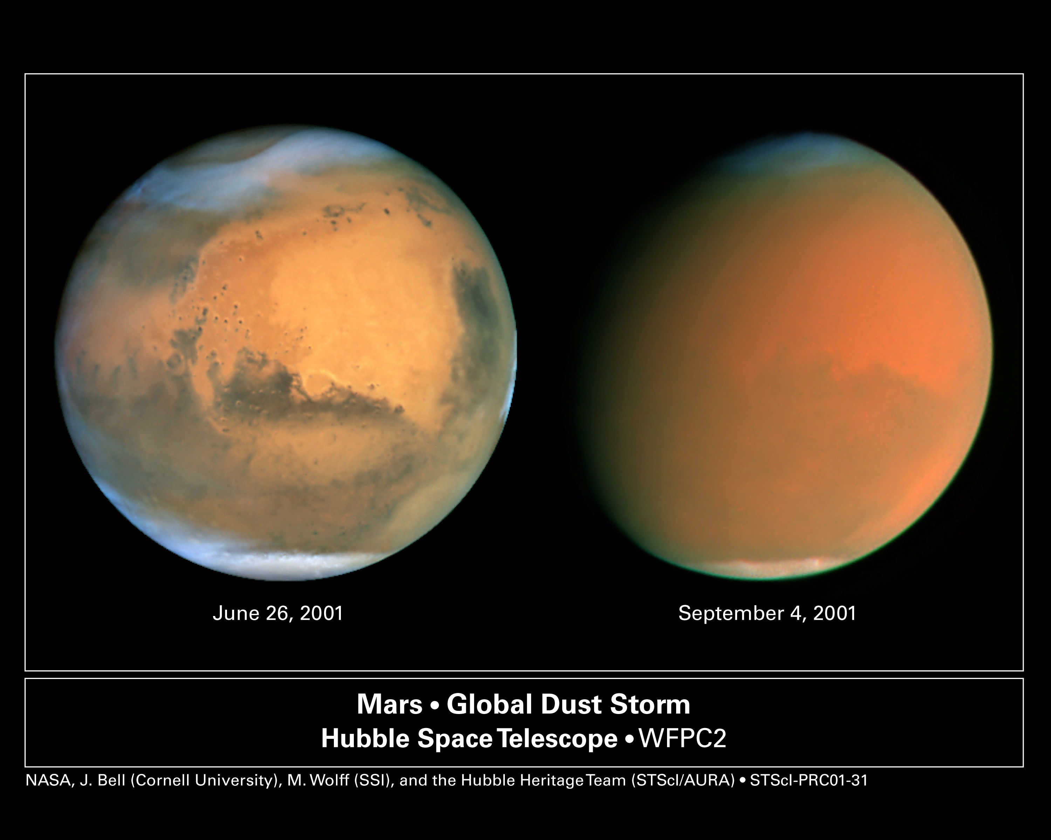
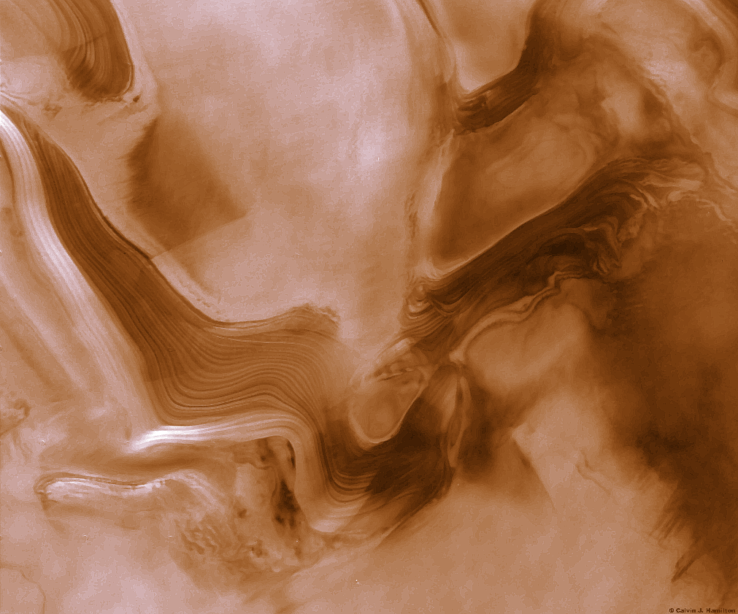
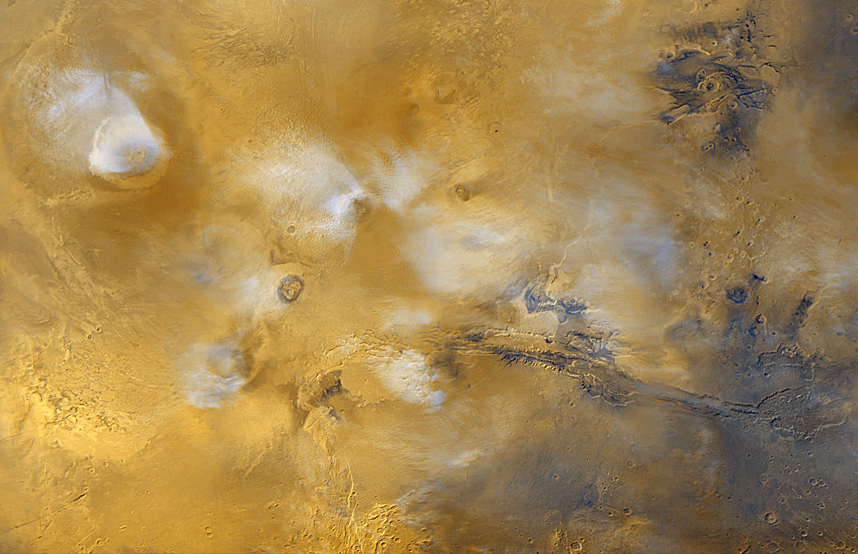
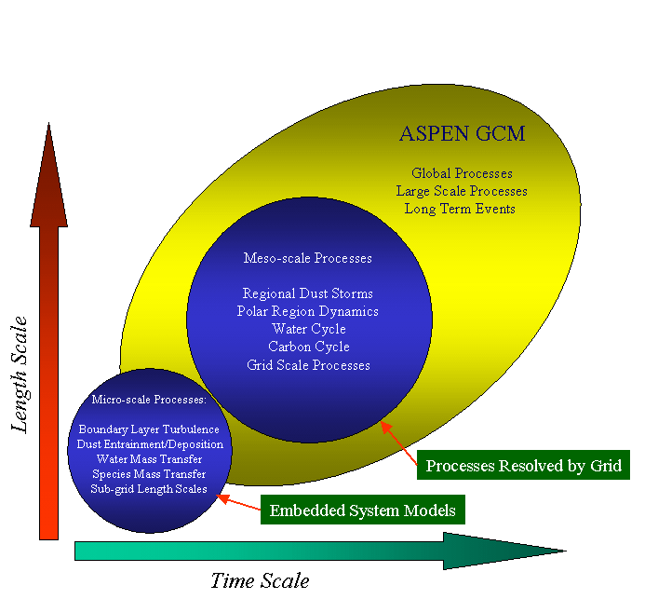

Figure 4. Hierarchical relationship of processes and the fundamental structure of embedded system solution approach. The inset pictures illustrate phenomena that can be characterized as either micro-scale, meso-scale, or global scale. The micro-scale image (lower left) is a photomosaic from the Mars Orbiter Camera aboard the Mars Global Surveyor and captures the presence of fan-shaped clouds that form on the leeward side of the shield volcanoes on the Tharsis rise. The meso-scale image (center) is a Viking 2 picture of the Martian north polar cap in which visible layering is present and is likely the result of wind borne dust settling upon the polar cap and differentially sedimenting due to climatic variations. The global scale image (right) is a two picture sequence from the Hubble Space Telescope and shows a comparison of Mars during a relatively calm period, and three months later when a storm has engulfed the entire planet.

The embedded systems approach will be implemented here through the use of overset grid methods. One approach to implementing overset grids is to construct a background grid resolving the entire simulation domain. Then additional grids, secondary grids, are placed in the background grid system. These secondary or overset grids would then define the region of an embedded component, such as a chemical species or turbulent flow region. The overset grid system would have a grid resolution that is significantly finer than the base grid system allowing for a greater fidelity solution to the governing equation set. No attempt is made to align the grid points of the background grid with those of the overset grids. Instead, the fluid flow equations are solved on the background grid and then separately on the overset grids in a hierarchical technique that is based on the structure of the grid system and the relationship between grids. Through interpolation, the overset grids use the current flow solution on the background grid as intermediate boundary conditions in a sub-iterative solution. Conversely, the background grid disregards those regions that are lying under an overset grid, instead adopting for the solution the interpolated updated values from the overset grid. This sub-iterative cycle of equation solution on a grid and intergrid data exchange is continued until a converged solution is achieved (based on a minimum global residual), and in this way, the solutions on the overset and background grids are fully coupled. Through the use of an embedded overset grid method, the relatively fine grid resolution required by a turbulence model of the planetary boundary layer is achieved while minimizing the overall size of the grid set and thus results in tractable computational times.
2.7 Climate Change
The new Mars GCM will be a tool that can be used to study climate change on Mars. However, the proposed work described above is already very ambitious. If time permits, we will address the subject of climate change, but we anticipate requesting external funding for that aspect of the work that becomes possible with the new model.
One of the drivers of climate change on Mars is obliquity changes. Unlike the Earth, whose obliquity is stabilized by the Moon, Mars undergoes large changes in the tilt of its rotational axis. On timescales of ~100,000 years, Mars's obliquity varys from 10.8 to 38 degrees (it's now at 25.2). There are also ~1,000,000 year modulations in the amplitude of these obliquity oscillations. These obliquity changes are expected to lead to variations in the atmospheric pressure of 0.4 to 35 mbar due to sublimation of the polar caps. In addition, spin-orbit secular resonances may have occasionally led to much higher obliquities, with greater corresponding extremes in surface conditions. One such resonance within the last 5 million years may have led to obliquities approaching 45 degrees (Ward, 1992). Evidence for this quasi-periodic climate change is seen in the polar layered terrain, and in the current net southward flow of water. There may be complex feedback patterns involving the surface pressure, dust and clouds in the atmosphere, global circulation patterns and polar cap albedos. (Keiffer and Zent, 1992). The enigmatic "gully" features recently observed by the Mars Global Surveyor are distributed preferentially at high latitudes and on pole-ward facing slopes, leading to the suggestion that these features could have formed during an epoch of high obliquity, when maximum insolation would shift from the equator to these high latitude locations (Mellon and Phillips, 2001).

3. Schedule/Cost/Division of Labor
The multidivisional proposal team consists of SwRI scientists with backgrounds in planetary and atmospheric science, and with strong modeling backgrounds. The proposed work will involve existing SwRI scientists from Division 15 (San Antonio and Boulder), and from Division 18. The cost of the proposed work is $190K. Discussions of this proposal have also attracted three external participants, each of which is recognized as an expert in some domain of Mars science. At no cost to SwRI, the proposal team includes: Dr. Steve Bougher, who is one of the world’s foremost modelers of the Mars upper atmosphere; Dr. Steve Clifford, who is one of the foremost Mars hydrologists; Dr. Brad Dalton, who has used GCMs to predict balloon trajectories for mission planning.
The responsibilities and funding will be split between the efforts of various SwRI scientists, over a 12 month period, as follows:

Responsibility | Scientist | Division | Months of Work | Est. Cost
Overall, main model | Crowley | 15 | 0.8 | 19K
Radiative Transfer/dust | Bullock | 15 (Boulder) | 1.5 | 27K
Radiative Transfer/dust | Gladstone | 15 | Collaborator | 0
Ground-atmos. interaction | Huebner | 15 | 0.7 | 25K
Ground-atmos. interaction | Boice | 15 | 0.8 | 17K
Ground-atmos. interaction | L. Young | 15 (Boulder) | 1 | 18K
Boundary layer interact./dust | Freitas | 18 | 1 | 22K
D/H ratio, obliquity | D. Grinspoon | 15 (Boulder) | 1 | 22K
Ionosphere | R. Link | 15 | 1.6 | 40K

The proposed development will begin with appropriate changes to the ASPEN model to simulate Mars, including the changing of fixed parameters like the planetary radius, composition and chemistry. This will take about 3 calendar months, led by Dr. Crowley. At the same time, four parallel studies will begin. These are studies of: (1) boundary layer interactions (led by Dr. Freitas), including the ground-atmosphere interaction with the release and sequestration of various gases such as H₂O and CO₂ (led by Dr. Huebner); (2) the radiative transfer function for atmospheric dust (led by Dr. Bullock); (3) the D/H ratio (led by Dr. David Grinspoon); and (4) the Mars ionosphere (led by Dr. Richard Link). The goals of each sub-project are listed below. Within 6 months, modules will have been developed for the ground-atmosphere interaction, the boundary layer interactions and the radiative transfer problem. They will be included in the main model for experimentation and validation during months 7-9. The D/H and ionospheric modules will be completed in month 9, and validated in months 10-12.

3.1 Planetary Boundary Layer: Work Plan
The development of the PBL models will be broken into four subtasks. These subtasks are:
Task 1: Identify the relevant physical processes for modeling the Martian boundary layer with surface volatile interaction.
Task 2: Develop the necessary mathematical and algorithmic representations of the thermodynamic processes for modeling the pressure and temperature conditions present in the Martian surface and boundary layer environment.
Task 3: Outline algorithms and data needs for adapting the existing boundary layer code for Mars to incorporate the relevant physical processes.
Task 4: Couple the boundary layer code with surface interaction to the Mars GCM and prepare a demonstration simulation.

3.2 Radiative Transfer: Work Plan
The Venus radiative-convective atmosphere model will be adapted for modeling the Mars atmosphere. Aside from global parameters such as solar energy and gravity, few changes are necessary to correctly model radiative fluxes in the dust-free atmosphere of Mars with this code. However, a separate but similar module will be constructed to accurately deal with the absorption of sunlight, since this is not treated in the Venus atmosphere model. Correlated-k absorption coefficients for 55 spectral intervals in visible wavelengths will be calculated, using CO₂, H₂O, CO and O₃ as the gaseous absorbers. As with infrared wavelengths, fluxes and heating rates will be calculated using exponential sums and the source function method of [Toon et al., 1989].
Optical constants for palagonite from 0.3 to 25 μm are well characterized [Clark et al., 1990; Roush et al., 1991], and will be used in a Mie scattering model [Hansen and Travis, 1974] for calculating single scattering albedos and scattering asymmetry factors. Using these scattering parameters, as well as those for water ice, and the correlated-k absorption coefficients for gases, radiative fluxes and heating rates can be calculated accurately using the modified 2-stream radiative-convective model.
The cloud microphysical model CARMA will be adapated for use in the radiative transfer code by including the microphysics of CO₂ ice condensation of water ice in a CO₂ atmosphere. This combined radiative transfer/microphysical code will be tested against cloud observations by the Mars Global Surveyor Thermal Emission Spectrometer, by Mars Pathfinder datasets, and by Mars Odyssey THEMIS observations, if available.
Adapting the Venus code for Mars and the incorporation of dust optical constants and cloud microphysics will be performed by Co-I Bullock during the first 6 months the project, and will require approximately 4 man-weeks. PI Crowley will lead the tasks related to adapting CARMA for simulating Martian clouds. Existing workstations, databases and software at the Department of Space Studies in Boulder, Colorado, are more than adequate for the code development and testing. Integration of the dust, cloud, and radiative transfer code into the GCM will be performed by PI Crowley and Co-I Bullock during the second 6 month period of the 12 month project. Estimated work effort for this phase is 1 man-week of Crowley's time and 1 man-week of Bullock's time.
Task 1: Adapt the Venus thermal radiative-convective code to accurately calculate infrared fluxes and heating rates in the dust-free Mars atmosphere.
Task 2: Construct a visible wavelength model of radiative transfer in the Mars atmosphere based largely on the Venus code.
Task 3: Incorporate optical constants for palagonite dust in the Mars atmosphere, based on published optical constants and size distributions.
Task 4: Test the Mars dust/radiative-transfer code against published results in the literature.
Task 5: Incorporate the Mars dust/radiative transfer code into the SwRI Mars GCM.
3.3 D/H ratio: Work Plan
Recent observations by Krasnopolsky et al (1998), and theoretical modeling by Cheng et al (1999) and Bertaux and Montmessin (2001), have produced results which cast doubt on the actual fractionation factor for deuterium loss from Mars. The understanding of the fractionation factor is currently in flux, but we have working models developed which can simulate the evolution of deuterium and water on Mars for any fractionation factor.
The fractionation factor parameterizes the problem at the top of the atmosphere. At the bottom of the atmosphere is the boundary layer. We will make use of transport rates indicated by the results of the GCM in order to derive fluxes and fractionation values at the surface/atmosphere interface over seasonal and diurnal cycles. Eventually this will be expanded to cover obliquity cycles as well. This work will allow us to make much more sophisticated connections between the currently observed D/H ratio in the Martian atmosphere and the long term history of water on that planet.
Our work so far has led us to believe that fractionation of crustal water from a cometary source may be the most straightforward explanation of the observed atmospheric D/H (Grinspoon, 1999). However, if modern day exchange rates between the atmosphere and polar and crustal reservoirs are sufficiently rapid then these processes could dominate the currently observed atmospheric ratio. In other words, the steady-state value matches a cometary source very well, but the current atmosphere may not be in steady state if other exchanges dominate over a net flux through the atmosphere from the crust to the exosphere.
In order to test this possibility, and further understand the current atmospheric isotopes,we will attempt to consider all fractionation processes acting in the present and the past which may have affected the D/H observed in the Martian crust and atmosphere. In particular we will more carefully model the fractionation between crustal or polar cap sources of frozen water and a sublimated atmospheric reservoir. In our calculations so far, we have simply used a “characteristic” Martian surface temperature of 230K. In reality, this fractionation is temperature dependent, so our more realistic treatment will include an integration over the temperature variations actually found on Mars.
This model will be based on similar modeling which we have successfully applied to understanding isotopic ratios in the atmosphere of Venus (Grinspoon, 1993). This model will allow us to determine the influence of exchanges between the various reservoirs on the D/H in the Martian atmosphere. Modeling of this kind is essential for a deep understanding of the origin of the observed Martian atmospheric D/H ratio and the behavior and history of water on Mars.
3.4 Ionosphere: Work Plan
Task 1: Develop and code chemical reaction scheme (cf. Table XX).
Task 2: Compile and code reaction rate coefficients, diffusion coefficients, etc.
Task 3: Develop code for solution of coupled reaction-diffusion equations.
Task 4: Generate photoionization, photoelectron impact, and solar wind electron impact ionization rates for required range of solar conditions
- Generate  5-6 profiles spanning solar minimum to maximum.
- Develop interpolation routine for intermediate solar activities.
- Develop interface between ionization and chemistry models.
Task 5: Integrate and validate chemistry model.
Task 6: Incorporate magnetic field model from Mars Global Surveyor measurements.
Task 7: Integrate ion chemistry and magnetic field models into Mars atmospheric model.

4. Benefits to the Institute
- Brings together existing SwRI scientists in a new and synergistic team knowledgable about Mars research issues
- Provides a forum to involve Mars experts from outside SwRI
- Results in the development of a major new capability relevant to Mars work (advanced model of Mars’ atmosphere)
- Results in recognition of SwRI as a contributor to the Mars community
- Places SwRI in a competitive position to contribute to existing and future Mars missions

5. Business Plan
NASA is placing great emphasis on Mars science and exploration, and is planning to launch approximately two missions to Mars at each two-year opportunity through at least 2009. The NASA budget for Mars research is currently at the $350 million/year level and increasing. Development of the SwRI Mars Atmosphere Model will provide a state-of-the-art tool (not presently in existence) for making mission-critical decisions and for addressing some of the most fundamental issues in Mars science.
Figure 5 provides the vision for our business plan on a timescale of 1-5 years. At the center of the vision is the SwRI Mars GCM. Overlapping the GCM and the SwIM program are various circles representing different functional groups that we perceive as potential clients. In the circles are the organizational names and geographical locations, and they include different parts of NASA and the NSF. Green circles represent organizations where we already have contacts, and in several cases we already receive funding from those groups. Red circles denote organizations where we do not have close contacts.

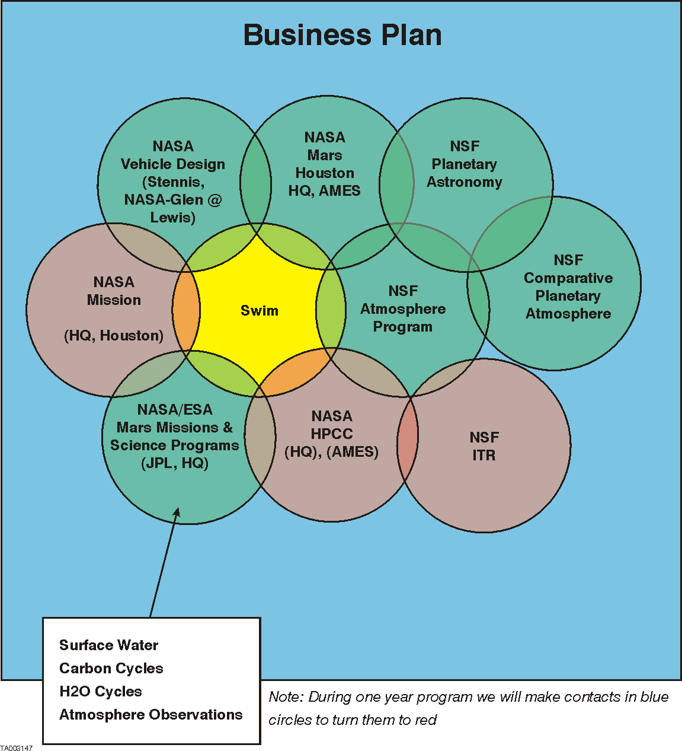
Figure 5. Vision and business plan for the SwRI Mars GCM

Current Mars general circulation models are inadequate for predicting the state of the atmosphere for such tasks as reliable spacecraft aerobrake capture and for the safety and navigation of balloons and aircraft. For example, during Mars Global Surveyor aerobraking, the onset, rise and decay of a regional dust storm caused an unanticipated 8 km inflation of the atmosphere, with a factor of 3 increase in density at 130 km [Albee et al., 2001]. Dust loading associated with storms of all sizes dramatically alter regional and even global atmospheric temperature structures on rapid timescales. Currently available general circulation models have been unable to predict how and when dust storms arise, and by what mechanisms they dissipate. Predictive knowledge of the state of the atmosphere due to dust and clouds is an absolute prerequisite for the navigation and safety of the new generation of sophisticated missions, and is a key goal of the proposed integrated modeling effort. A major part of our marketing plan is to demonstrate in the scientific literature the effectiveness of our model for detailed predictions of the martian atmosphere, while simultaneously working with mission design personnel at NASA, JPL, APL, Ball Aerospace and Lockheed Martin to secure major contracts for future Mars mission support. We have the support of a key player in these endeavors already; Dr. Steve Bougher of the Lunar and Planetary Laboratory at the University of Arizona was deeply involved in developing atmospheric predictions for the Mars Global Surveyor mission and he is an enthusiastic collaborator on this proposal.
A Mars balloon mission has been an objective of international Mars exploration programs for over a decade. An improved Mars GCM would be of great assistance in planning prospective missions deploying airborne instruments to characterize the Martian surface and atmosphere. Dr. Dalton collaborated on the Russian/French Mars Balloon project originally intended for deployment with the Mars '94-'96 joint spacecraft mission. Dr. Dalton developed a simulation program based on the engineering specifications of the French Mars Balloon, and interfaced it with the NASA-Ames Mars GCM (Pollack et al., 1990). This model was used to predict the daily motion of the balloon, its response to atmospheric conditions of dust loading, irradiation, pressure, temperature and wind fields, as well as the fluctuations of the daily solar cycle. The trajectory of the balloon over the course of the nominal mission was derived based on GCM
simulations appropriate to a number of candidate landing sites. Potential hazards to the balloon were evaluated, in particular the effects of trajectories over rough terrain. The final choice of landing site was then and in the future will be highly dependent on predicted trajectories, with emphasis on maximizing science return while minimizing hazards to the balloon. Though the modeling effort was successful (Dalton and Pollack, 1990), the Mars '94 Mission was canceled as a result of political and economic difficulties in the former Soviet Union.
Scientific and popular international support for a Martian Balloon Mission remains strong, and such a mission is inevitable. In the twelve years since the original modeling effort, observational and theoretical work has significantly improved the capabilities of modern GCMs. Dr. Dalton is familiar with the implicit restrictions placed on trajectory simulations by the limitations of early GCMs. A new GCM model would be critical to future Martian balloon deployment, and would result in improved science return, wider safety margins, higher confidence levels, and enhanced mission success. Once a new Mars GCM becomes available, the existing Mars balloon model can be interfaced with the GCM through straightforward modifications in the pressure, temperature, and wind field handling modules. The original program was designed for easy modification, and can be adapted to new engineering specifications for advanced balloon designs by altering parameter blocks expressly designed for this purpose. For this reason, enhancements to the physical balloon model are also straightforward. Once completed, the new Mars Balloon / GCM combined model would be applied to questions of balloon behavior, motion, sensitivity to atmospheric conditions, and trajectory to evaluate mission planning and landing site criteria. Applications to other airborne missions can be derived by similar methods.
In addition, the SwRI Mars general circulation model will provide numerous additional opportunities to bring new business to SwRI by directly seeding a suite of Mars R&A proposals to be written in 2002 and 2003. These opportunities can be broadly characterized by the key NASA Astrobiology theme, 'Follow the water'. By paying particular attention to the physics of the planetary boundary layer, turbulence, subsurface water distribution (with collaborator Dr. Steve Clifford at the Lunar and Planetary Science Institute), clouds and dust processes, our model will be well positioned to make new discoveries on the history, distribution and availability of water in the martian environment. As such, it will be an unparalleled tool for guiding both theoretical investigations into the search for extinct or extant life on Mars, and for informing landing site selection of particular geochemical and exobiological interest.
With respect to specific upcoming missions, there is an opportunity to support the European Mars Express mission (2003 launch), for which Dr. Winningham (Div 15) is an instrument PI. There is also the opportunity to support the two Mars Exploration Rovers (launch 2003) that will perform atmospheric and surface measurements. Longer term, the development of this model will enhance the potential for SwRI to propose credible teams for later missions through 2009, including the Mars Scout series, for which Div 15 plans to propose atmospheric remote sensing instruments.
In summary, our business plan has three major goals:

- Create a state-of-the-art predicative model of the present Mars atmosphere and climate that will be the primary tool for mission planners for advanced missions to Mars (long-term contracts with NASA and/or aerospace companies).
- Develop the potential for evolutionary calculations of the nature, fate, and distribution of water that will answer fundamental scientific questions about the history of water on Mars. (long-term R&A contracts and grants tied to NASA science funding).
- Work with the larger Mars scientific and engineering communities by providing the best available resource for selecting landing sites of high geochemical and exobiological interest (long-term R&A contracts with NASA and/or aerospace companies).

6. Bibliography
Albee, A.L., R.E. Arvidson, F.D. Palluconi, and T. Thorpe, Overview of the Mars Global Surveyor mission, Journal of Geophysical Research, 106, 23,291-23,316, 2001.
Pollack, J.B., R.M. Haberle, J. Schaeffer, H. Lee, Simulations of the General Circulation of the Martian Atmosphere: 1. Polar Proceses, J. Geophys. Res., 95, 1447-1473, 1990.
Dalton, J.B. and J.B. Pollack, Exploring Mars by Balloon: Results of GCM
Simulations, Proc. of the Case for Mars IV, Boulder CO 1990.
Bullock, M.A., and D.H. Grinspoon, The recent evolution of climate on Venus, Icarus, 150, 19-37, 2001.
Clancy, R.T., and S.W. Lee, A New Look at Dust and Clouds in the Mars Atmosphere: Analysis of Emission-Phase-Function Sequences from Global Viking IRTM Observations, Icarus, 93, 135 - 158, 1991.
Clancy, R.T., S.W. Lee, G.R. Gladstone, W.W. McMillan, and T.L. Roush, A new model for Mars atmospheric dust based upon analysis of ultraviolet through infrared observations from Mariner 9, Viking, and Phobos, Journal of Geophysical Research, 100, 5251-5264, 1995.
Clark, R.N., G.A. Swayze, R.B. Singer, and J.B. Pollack, High resolution reflectance spectra of Mars in the 2.3 mm region: Evidence for the mineral scapolite, Journal of Geophysical Research, 95, 14,463-14,480, 1990.
Colaprete, A., and O.B. Toon, The radiative effects of martian water ice clouds on the local atmospheric temperature profile, Icarus, 145, 524-532, 2000.
Crisp, D., Infrared radiative transfer in the dust-free Martian atmosphere, Journal of Geophysical Research, 95, 14,577-14,588, 1990.
Crisp, D., D.A. Allen, D.H. Grinspoon, and J.B. Pollack, The dark side of Venus: Near-infrared images and spectra from the Anglo-Australian Observatory, Science, 253, 1263 - 1266, 1991.
de Bergh, C., B. Bezard, D. Crisp, J.P. Maillard, T. Owen, J.B. Pollack, and D.H. Grinspoon, Water in the deep atmosphere of Venus from high-resolution spectra of the night side, Advances in Space Research, 15, (4)79-(4)88, 1995.
Gruszka, M., and A. Borysow, Roto-translational collision-induced absorption of CO₂ for the atmosphere of Venus at frequencies from 0 to 250 cm⁻¹ at temperatures from 200 to 800 K, Icarus, 129, 172-177, 1997.
Haberle, R.M., M.M. Joshi, J.R. Murphy, J.R. Barnes, J.T. Shofield, J.T. Wilson, M.A. Lopez-Valverde, J.L. Hollingsworth, A.F.C. Bridger, and J. Schaeffer, General circulation model simulation of the Mars Pathfinder atmospheric structure instrument/meteorology data, Journal of Geophysical Research, 104, 8957-8974, 1999.
Hansen, J.E., and L.D. Travis, Light scattering in planetary atmospheres, Space Science Reviews, 16, 527-610, 1974.
Hunt, G.E., Thermal infrared properties of the Martian atmosphere. 4. Predictions of the presence of dust and ice clouds from Viking IRTM spectral measurements, Journal of Geophysical Research, 84, 2865-2874, 1979.
Kahn, R.A., T.Z. Martin, R.W. Zurek, and S.W. Lee, The Martian dust cycle, in Mars, edited by H.H. Kieffer, B.M. Jakosky, C.W. Snyder, and M.S. Matthews, pp. 1017-1053, University of Arizona Press, Tucson, 1992.
Kieffer, H.H., B.M. Jakosky, and C.W. Snyder, The planet Mars: From antiquity to the present, in Mars, edited by H.H. Kieffer, B.M. Jakosky, C.W. Snyder, and M.S. Matthews, pp. 1-33, University of Arizona Press, Tucson, 1992.
Kliore, A., V.I. Moroz, and G.M. Keating, The Venus International Reference Atmosphere, in COSPAR, Pergamon Press, Oxford, 1986.
Knollenberg, R.G., and D.M. Hunten, The microphysics of the clouds of Venus: Results of the Pioneer Venus particle size spectrometer experiment, Journal of Geophysical Research, 85, 8039-8058, 1980.
Lacis, A.A., and V. Oinas, A description of the correlated k method for modeling nongray gaseous absorption, thermal emission and multiple scattering in vertically inhomogeneous atmospheres, Journal of Geophysical Research, 96, 9027 - 9063, 1991.
Liou, K.N., Radiation and Cloud Processes in the Atmosphere, 487 pp., Oxford University Press, New York, 1992.
McKay, C.P., J.B. Pollack, and R. Courtin, The thermal structure of Titan's atmosphere, Icarus, 80, 23-53, 1989.
Meadows, V.S., and D. Crisp, Ground-based near-infrared observations of the Venus night side: The thermal structure and water abundance near the surface, Journal of Geophysical Research, 101, 4595-4622, 1996.
Pollack, J.B., Climate change on the terrestrial planets, Icarus, 37, 479-553, 1979.
Pollack, J.B., D. Colburn, F.M. Flasar, R. Kahn, C.E. Carlston, and D.C. Pidek, Properties and effects of dust particles suspended in the Martian atmosphere, Journal of Geophysical Research, 84, 2929-2945, 1979.
Pollack, J.B., D. Colburn, R. Kahn, J. Hunter, W. Van Camp, C.E. Carlston, and M.R. Wolf, Properties of aerosols in the Martian atmosphere, as inferred from Viking Lander imaging data, Journal of Geophysical Research, 82, 4479-4496, 1977.
Pollack, J.B., J.B. Dalton, D.H. Grinspoon, R.B. Wattson, R. Freedman, D. Crisp, D.A. Allen, B. Bezard, C. de Bergh, L.P. Giver, Q. Ma, and R.H. Tipping, Near infrared light from Venus' nightside: A spectroscopic analysis, Icarus, 103, 1-42, 1993.
Pollack, J.B., R.M. Haberle, J. Schaeffer, and H. Lee, Simulations of the general circulation of the Martian atmosphere. I. Polar processes, Journal of Geophysical Research, 95, 1447-1473, 1990.
Rothman, L.S., C.P. Rinsland, A. Goldman, S.T. Massie, D.P. Edwards, J.M. Flaud, A. Perrin, C. Camy-Peyret, V. Dana, J.Y. Mandin, J. Schroeder, A. McCann, R.R. Gamache, R.B. Watson, K. Yoshino, K.V. Chance, K.W. Jucks, L.R. Brown, V. Nemtchinov, and R. Varanasi, The HITRAN molecular spectroscopic database and HAWKS (HITRAN Atmospheric Workstation): 1996 edition, Journal of Quantitative Spectroscopy and Radiative Transfer, 60, 665-710, 1998.
Rothman, L.S., R.B. Wattson, R.R. Gamache, D. Goorvith, R.L. Hawkins, J.E.A. Selby, C. Camy-Peyret, J.M. Flaud, J. Schroeder, and A. McCann, HITEMP, the high-temperature molecular spectroscopic database, Journal of Quantitative Spectroscopy and Radiative Transfer, in press, 1997.
Roush, T.L., J.B. Pollack, and J. Orenberg, Derivation of midinfrared (5-25 mm) optical constants of some silicates and palagonite, Icarus, 94, 191-208, 1991.
Tisdale, R.T., D.L. Glandorf, M.A. Tolbert, and O.B. Toon, Infrared optical constants of low temperature H₂SO₄ solutions representative of stratospheric sulfate aerosols, Journal of Geophysical Research, 103, 25353-25370, 1998.
Tomasko, M.G., L.R. Doose, P.H. Smith, and A.P. Odell, Measurements of the flux of sunlight in the atmosphere of Venus, Journal of Geophysical Research, 85, 8167-8186, 1980.
Toon, O.B., C.P. McKay, and T.P. Ackerman, Rapid calculation of radiative heating rates and photodissociation rates in inhomogeneous multiple scattering atmospheres, Journal of Geophysical Research, 94, 16287, 1989.
Toon, O.B., J.B. Pollack, and C. Sagan, Physical properties of the particles composing the Martian dust storm of 1971-1972, Icarus, 30, 663-696, 1977.
van de Hulst, H.C., Light Scattering by Small Particles, Dover, New York, 1981.
Ahrens, T.J., J.D. O’Keefe and M.A. Lange (1989) Formation of atmospheres during accretion of the terrestrial planets. in S.K. Atreya, J.B. Pollack and M.S. Matthews eds. Origin and Evolution of Planetary and Satellite Atmospheres. University of Arizona Press, Tucson.
Bertaux, J-L, and F. Montmessin. (2001). Isotopic fractionation through water vapor condensation: The Deuteropause, a cold trap for deuterium in the atmosphere of Mars. J. Geophys Res. 106, 32,879-32884.
Bjoraker, G.L., M.L. Mumma, and H.P. Larson (1989). Isotopic abundance ratios for hydrogen and oxygen in the Martian atmosphere, Bull. Am. Astron. Soc., 21, 991.
Bockelee-Morvan, D. et al. (1999) Icarus
Carr, M.H. (1986) Mars: A water rich planet? Icarus, 68, 187-216.
Carr, M,H, (1990). D/H on Mars: Effects of floods, impacts, volcanism and polar processes, Icarus, 87, 210-227.
Cheng, B.H. et al. Photo-induced fractionation of water isotopomers in the Martian atmosphere, Geophys. Res. Lett., 26, 3657-33660, 1999.
Donahue, T.M. (1995) Evolution of water reservoirs on Mars from D/H ratios in the atmosphere and crust, Nature, 374, 432-434.
Dreibus G. and H. Wanke (1989) Supply and loss of volatile constituents during the accretion of the terrestrial planets. in S.K. Atreya, J.B. Pollack and M.S. Matthews eds. Origin and Evolution of Planetary and Satellite Atmospheres. University of Arizona Press, Tucson.
Eberhardt, P., Reber, M. Krankowsky, D. & Hodges, R.R. Astron. Astrophys. 302, 301 (1995).
Fernandez, J.A. and W.-H.Ip (1983) Dynamical evolution of a cometary swarm in the ouer planetary region. Icarus ,47, 470-479.
Grinspoon, D.H. (1987). Was Venus wet? Deuterium reconsidered. Science, 238, 1702-1704.
Grinspoon, D. H. and J. S. Lewis (1987). Deuterium fractionation in the pre-solar nebula: Kinetic limitations on surface catalysis. Icarus, 72, 430-436.
Grinspoon, D. H. and J. S. Lewis (1988). Cometary water on Venus: Implications of stochastic impacts. Icarus, 74, 21-35.
Grinspoon, D. H. and J.S. Lewis (1989). A proposed explanation of the mysterious Venusian water profile. Bull. Am. Astron. Soc. 21, 924.
Grinspoon, D.H. (1993) Implications of the high deuterium-to-hydrogen ratio for the sources of water in Venus' atmosphere. Nature. 363, 428-431.
Grinspoon, D.H. (1999). Cometary water on Mars. Bull. Amer. Ast. Soc. 31, 1184.

Grinspoon, D.H. (1999) Evolution of Atmospheres on Terrestrial Planets. EOS, Abstract for invited talk at the Spring 1999 AGU meeting, Boston.
Hartmann, W.K. (1995) Planetary Cratering 1. The question of multiple impactor populations: Lunar evidence. Meteoritics 30.
Hubbard, W.B. and J.J. MacFarlane (1980). Theoretical predictions of deuterium abundances in the Jovian planets. Icarus 44, 676-682.
Jakosky, B.M. (1990). Mars atmospheric D/H: Consistent with polar volatile theory?. J. Gephys. Res. 95, 1475-1480.
Krasnopolsky, V.A., M.J. Mumma, and G.R. Gladstone, Detection of atomic Deuterium in the upper atmosphere of Mars, Science, 280, 1576-1580, 1998.
Lecluse, C. and F. Robert. (1994). Hydrogen isotope exchange reaction rates: Origin of water in the inner solar system. Geochimica et Cosmochimica Acta. 58, 2927-2939.
Matsui, T. and Y. Abe (1986) Evolution of an impact-induced atmosphere and magma ocean on the accreting Earth. Nature, 319, 303-305.
Meier, R. et al. Science 279, 842-844 (1998).
Owen, T., B.L. Lutz and C. de Bergh (1986) Deuterium in the outer solar system: Evidence for two distinct reservoirs. Nature 320, 244-246.
Watson, L.L., D. Hutcheon, S. Epstein, and E.M. Stolper. (1994). Water on Mars: Clues from deuterium/hydrogen and water contents of hydrous phases in SNC meteorites, Science, 265, 86-90.
Weissman, P.R. (1982). Dynamical history of the Oort cloud. In Comets, ed. L.L. Wilkening (Tucson: Univ. of Arizona Press), pp. 637-658.
Yung, Y.L., J.-S. Wen, J.P. Pinto, M. Allen, K.K. Pierce, and S. Paulsen (1988). HDO in the Martian atmosphere: Implications for the abundance of crustal water, Icarus, 76, 146-159.
Zahnle, K.J., J.F. Kasting, and J.B. Pollack (1988) Evolution of a steam atmosphere during Earth’s accretion. Icarus, 74, 62-97.
James et al. 1992. The seasonal cycle of carbon dioxide on Mars.
In Mars, Kieffer et al eds., Univ. of Arizona.
Jakosky and Haberle et al. 1992. The seasonal cycle of water on Mars.
In Mars, Kieffer et al eds., Univ. of Arizona.
Leiber, Fritz, 1951. A pail of air. Galaxy.
Pollack and Toon 1982. A Quasi-periodic climate change on Mars: a review. Icarus 50, 259-287.
Stansberry et al. 1992. Triton's surface-atmosphere energy balance.
Icarus 99, 242-260.
Stansberry et al 1996. A model for the overabundance of methane in the atmospheres of Pluto and Triton. Pl. Space. Si. vol 44. 1051-1061.
Yelle et al. 1991. Energy balance and plume dynamics in Triton's lower atmosphere. Icarus 89, 347-358.
Smith et al. Icarus 124, 586-597 (1996). Retrieval of atmospheric temperatures in the martian planetary boundary layer using upward-looking infrared spectra.
Savijarvi. Icarus 117, 120-127 (1995). Mars boundary layer modeling: diurnal moisture
cycle and soil properties at the Viking Lander 1 site.
Savijarvi. Contrib Atmos Phys 64, 219-229 (1991). A model study of the PBL structure on Mars and Earth. .
Jakosky et al Icarus 130. 87-95 (1997). The Mars water cycle: determining the role of exchange with the regolith.
Zent et al. J. Geophys. Res. 98, 3319-3338 (1993).
Jakosky et al. Icarus 130, 87-95 (1997).
J. A. Ryan, R. D. Sharman, and R. D. Lucich 1982. J. Geophys. Res.87,7279-7284
Houben. Advances in Space Research 23, 1587-1590 (1999).
Bauer, S. J., Physics of Planetary Ionospheres, Springer Verlag, New York, 1973.
Crank, J., The Mathematics of Diffusion, Oxford University Press, Oxford, 1980.

