**Appendix A. Supplementary Materials**

**A.1. Supplementary Figures:**

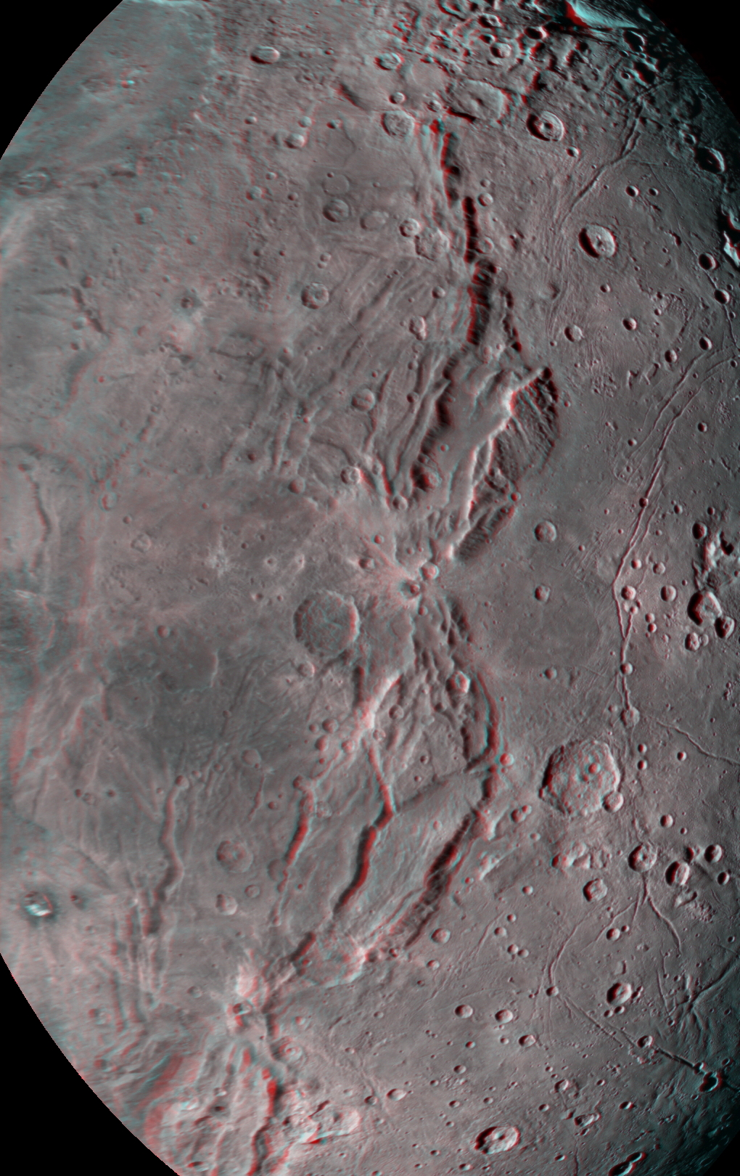

**Supplementary Figure 1 :** Red-blue stereo pair of region shown in Fig. 9a, highlighting the troughs and titled blocks along the boundary between the disrupted plains of Oz Terra (left side) and Vulcan Planitia (right side). The bounding trough (or moat) along the outer edge of the Vulcan Planitia is also evident. Note that orientation is different to align stereo pair for viewing. Image resolutions are ~1400 and 615 km/pixel. Figure format allows user to view in either wall-eyed mode (left-center) or cross-eyed mode (center-right).

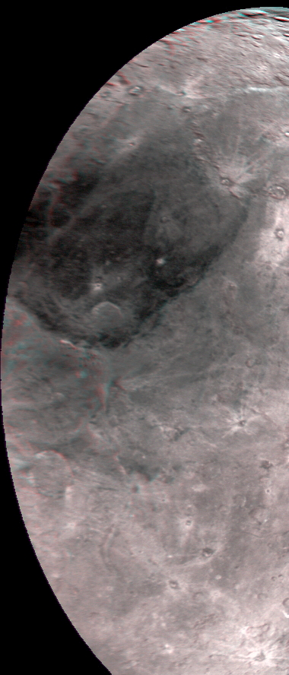

**Supplementary Figure 2 :** Red-blue stereo pair of region shown in Fig. 15a, highlighting the deep troughs and depressions, including Caleuche Chasma, near the north pole, and just below the large dark feature Mordor Macula. Note that orientation is different to align stereo pair for viewing. Image resolutions are ~1400 and 875 km/pixel.

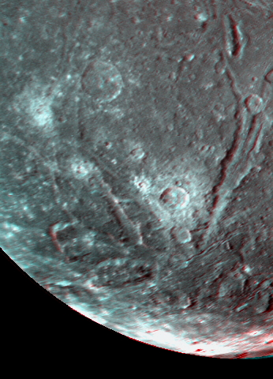

**Supplementary Figure 3 :** Red-blue stereo pair of angular and tilted crustal blocks on Uranian icy moon Ariel. Area shown is from lower left of Fig. 18. The best evidence for tilted blocks is in the bottom half of frame. Images are at resolutions of 1.0 and 1.25 km/pixel.

viewing.