SUPPLEMENTARY MATERIAL IMAGES
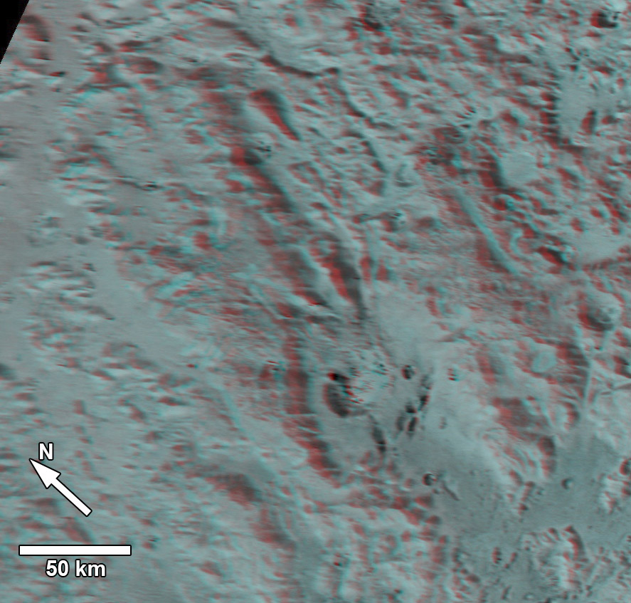
Fig. S1. Stereo Anaglyph of Rough-Mantled Terrain.

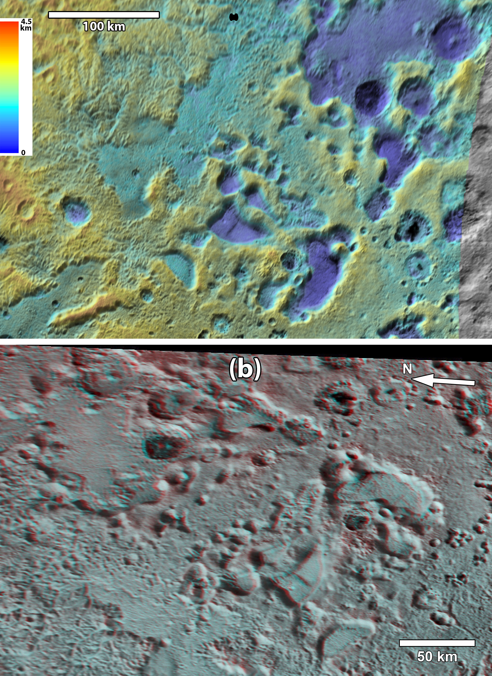
Fig. S2. Smooth Uplands and Pits terrain. (a) Copy of Fig. 4 without feature letters. North to top. Lambert Conformal Conic projection with standard parallels of 30°N and 50°N, with central meridian 210° E. (b) Stereo anaglyph image of region. Dissected Terrain at bottom of image, and Eroded Smooth Uplands terrain at upper right.
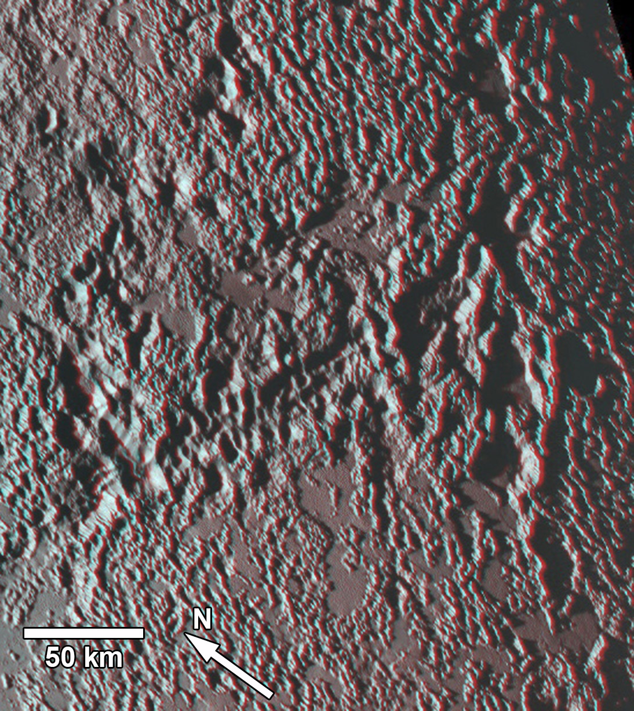

Fig. S3. Anaglyph image of Bright Pitted Uplands showing reticulate ridges, smooth lowlands which are consistent with conpositions rich in N₂, and deep pitting along structural lineations.
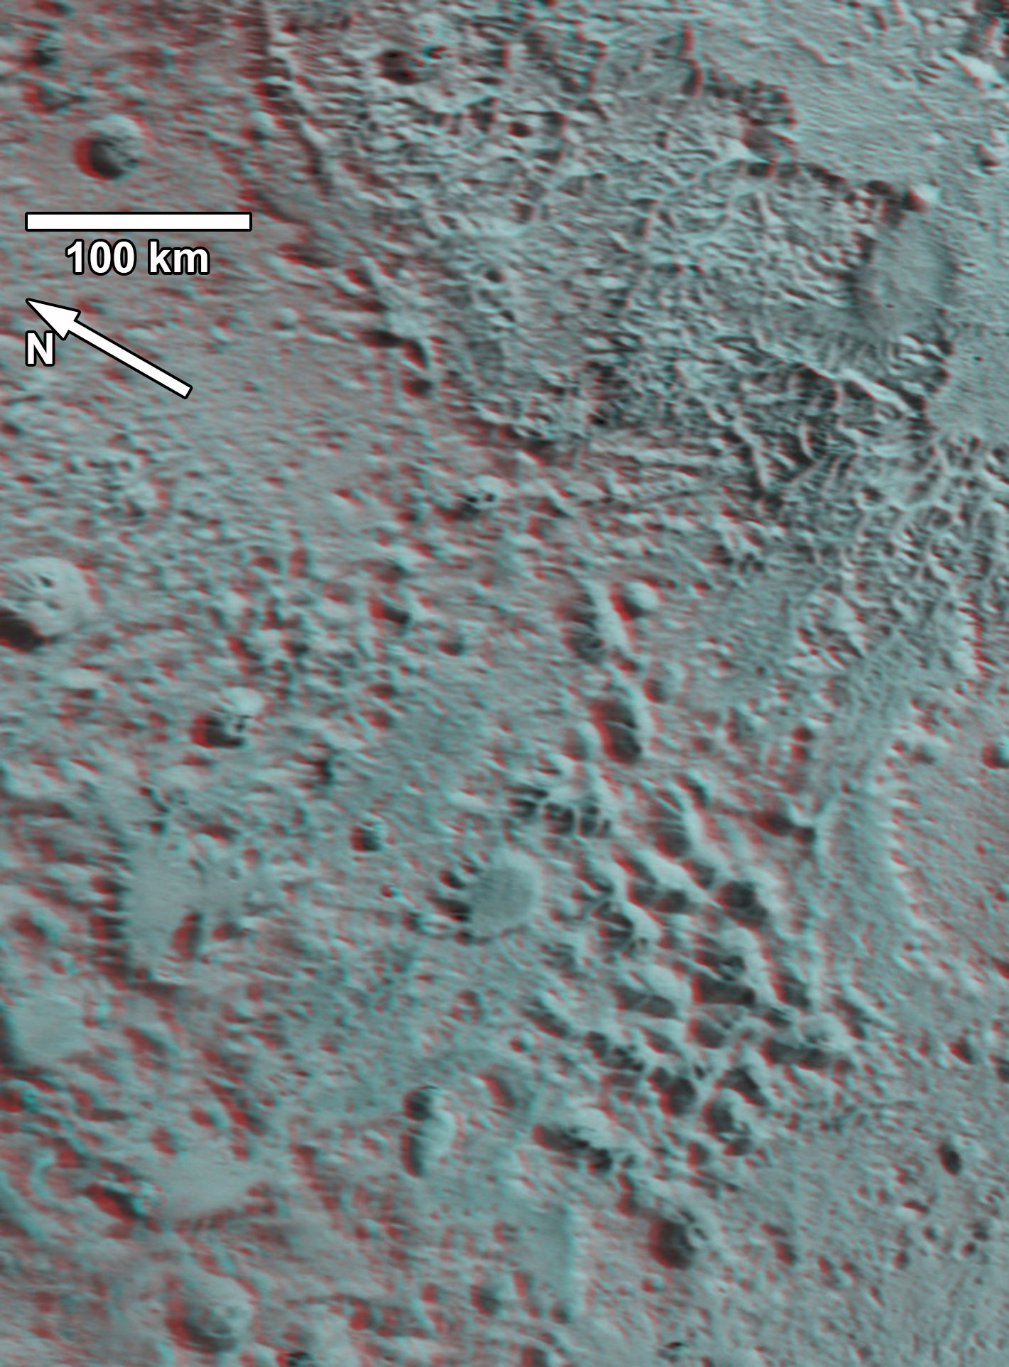
Fig. S4. Anaglyph image of large pit complex. Note continuation of pits along a structural trend extending to the upper left. Upper right of image is in Dissected Terrain, and lower left is in Northern Rough Uplands Terrain.
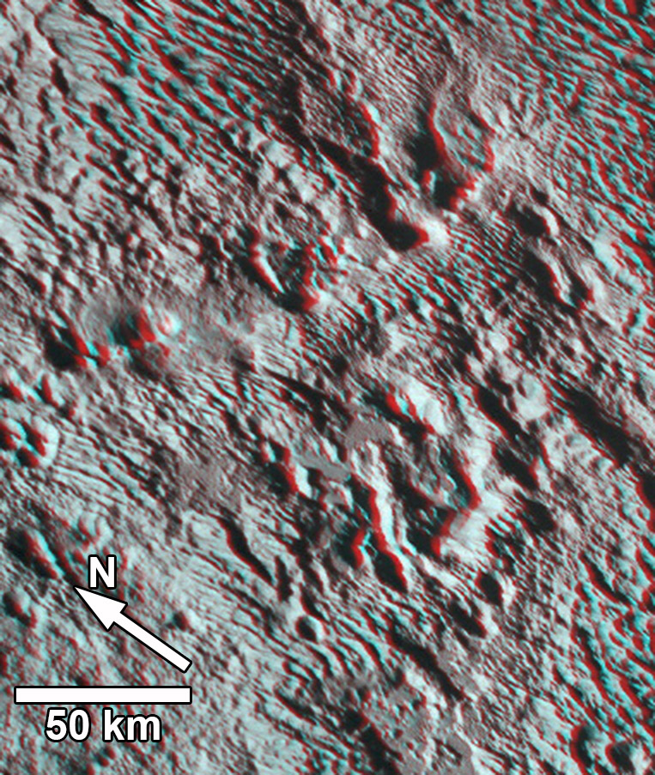
Fig. S5. Anaglyph images of deep pits, some of which are aligned along structural lineations. Uplands are covered with ridges of Bladed Terrain.
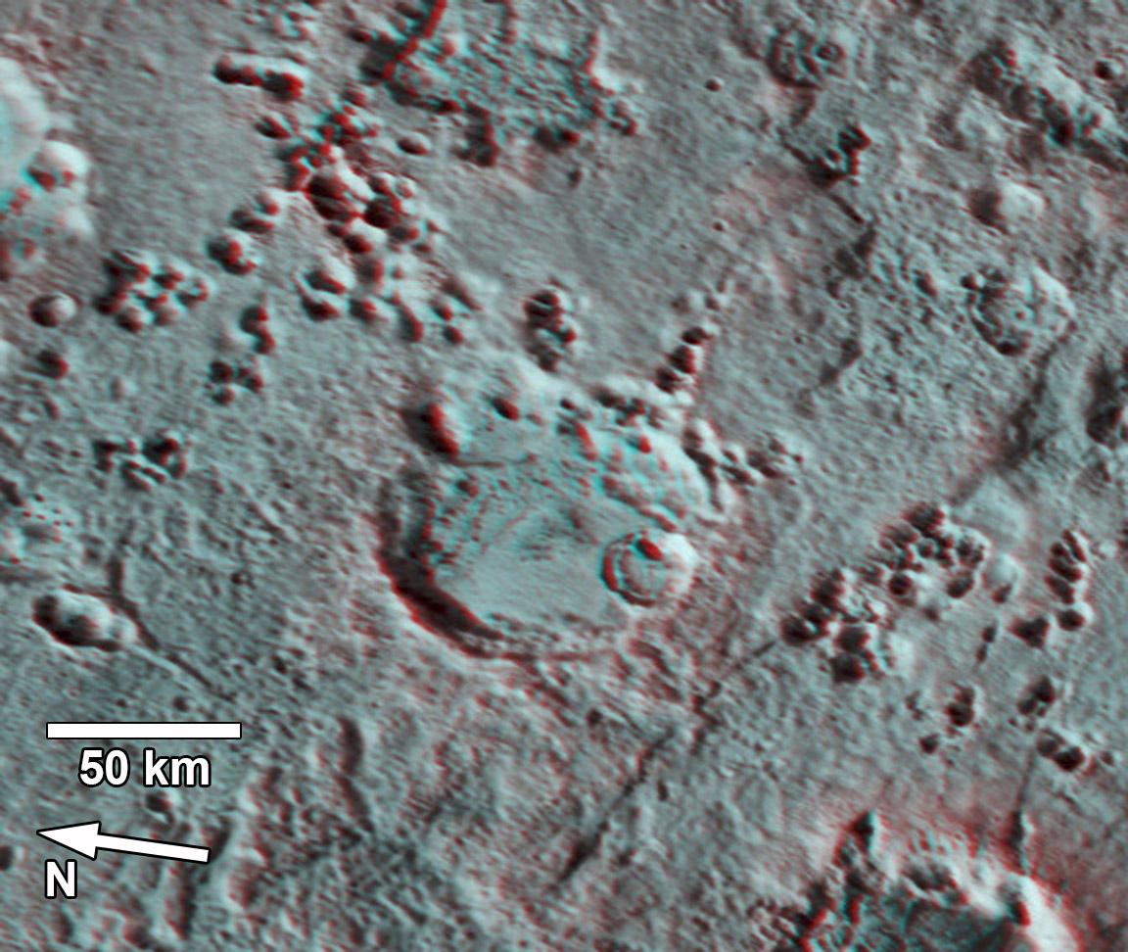
Fig. S6. Anaglyph image of smaller pits. Some of the pits may have slightly raised rims. Image located in Eroded Smooth Uplands terrain.

