SUPPLEMENTARY MATERIAL – FIGURES AND CAPTIONS

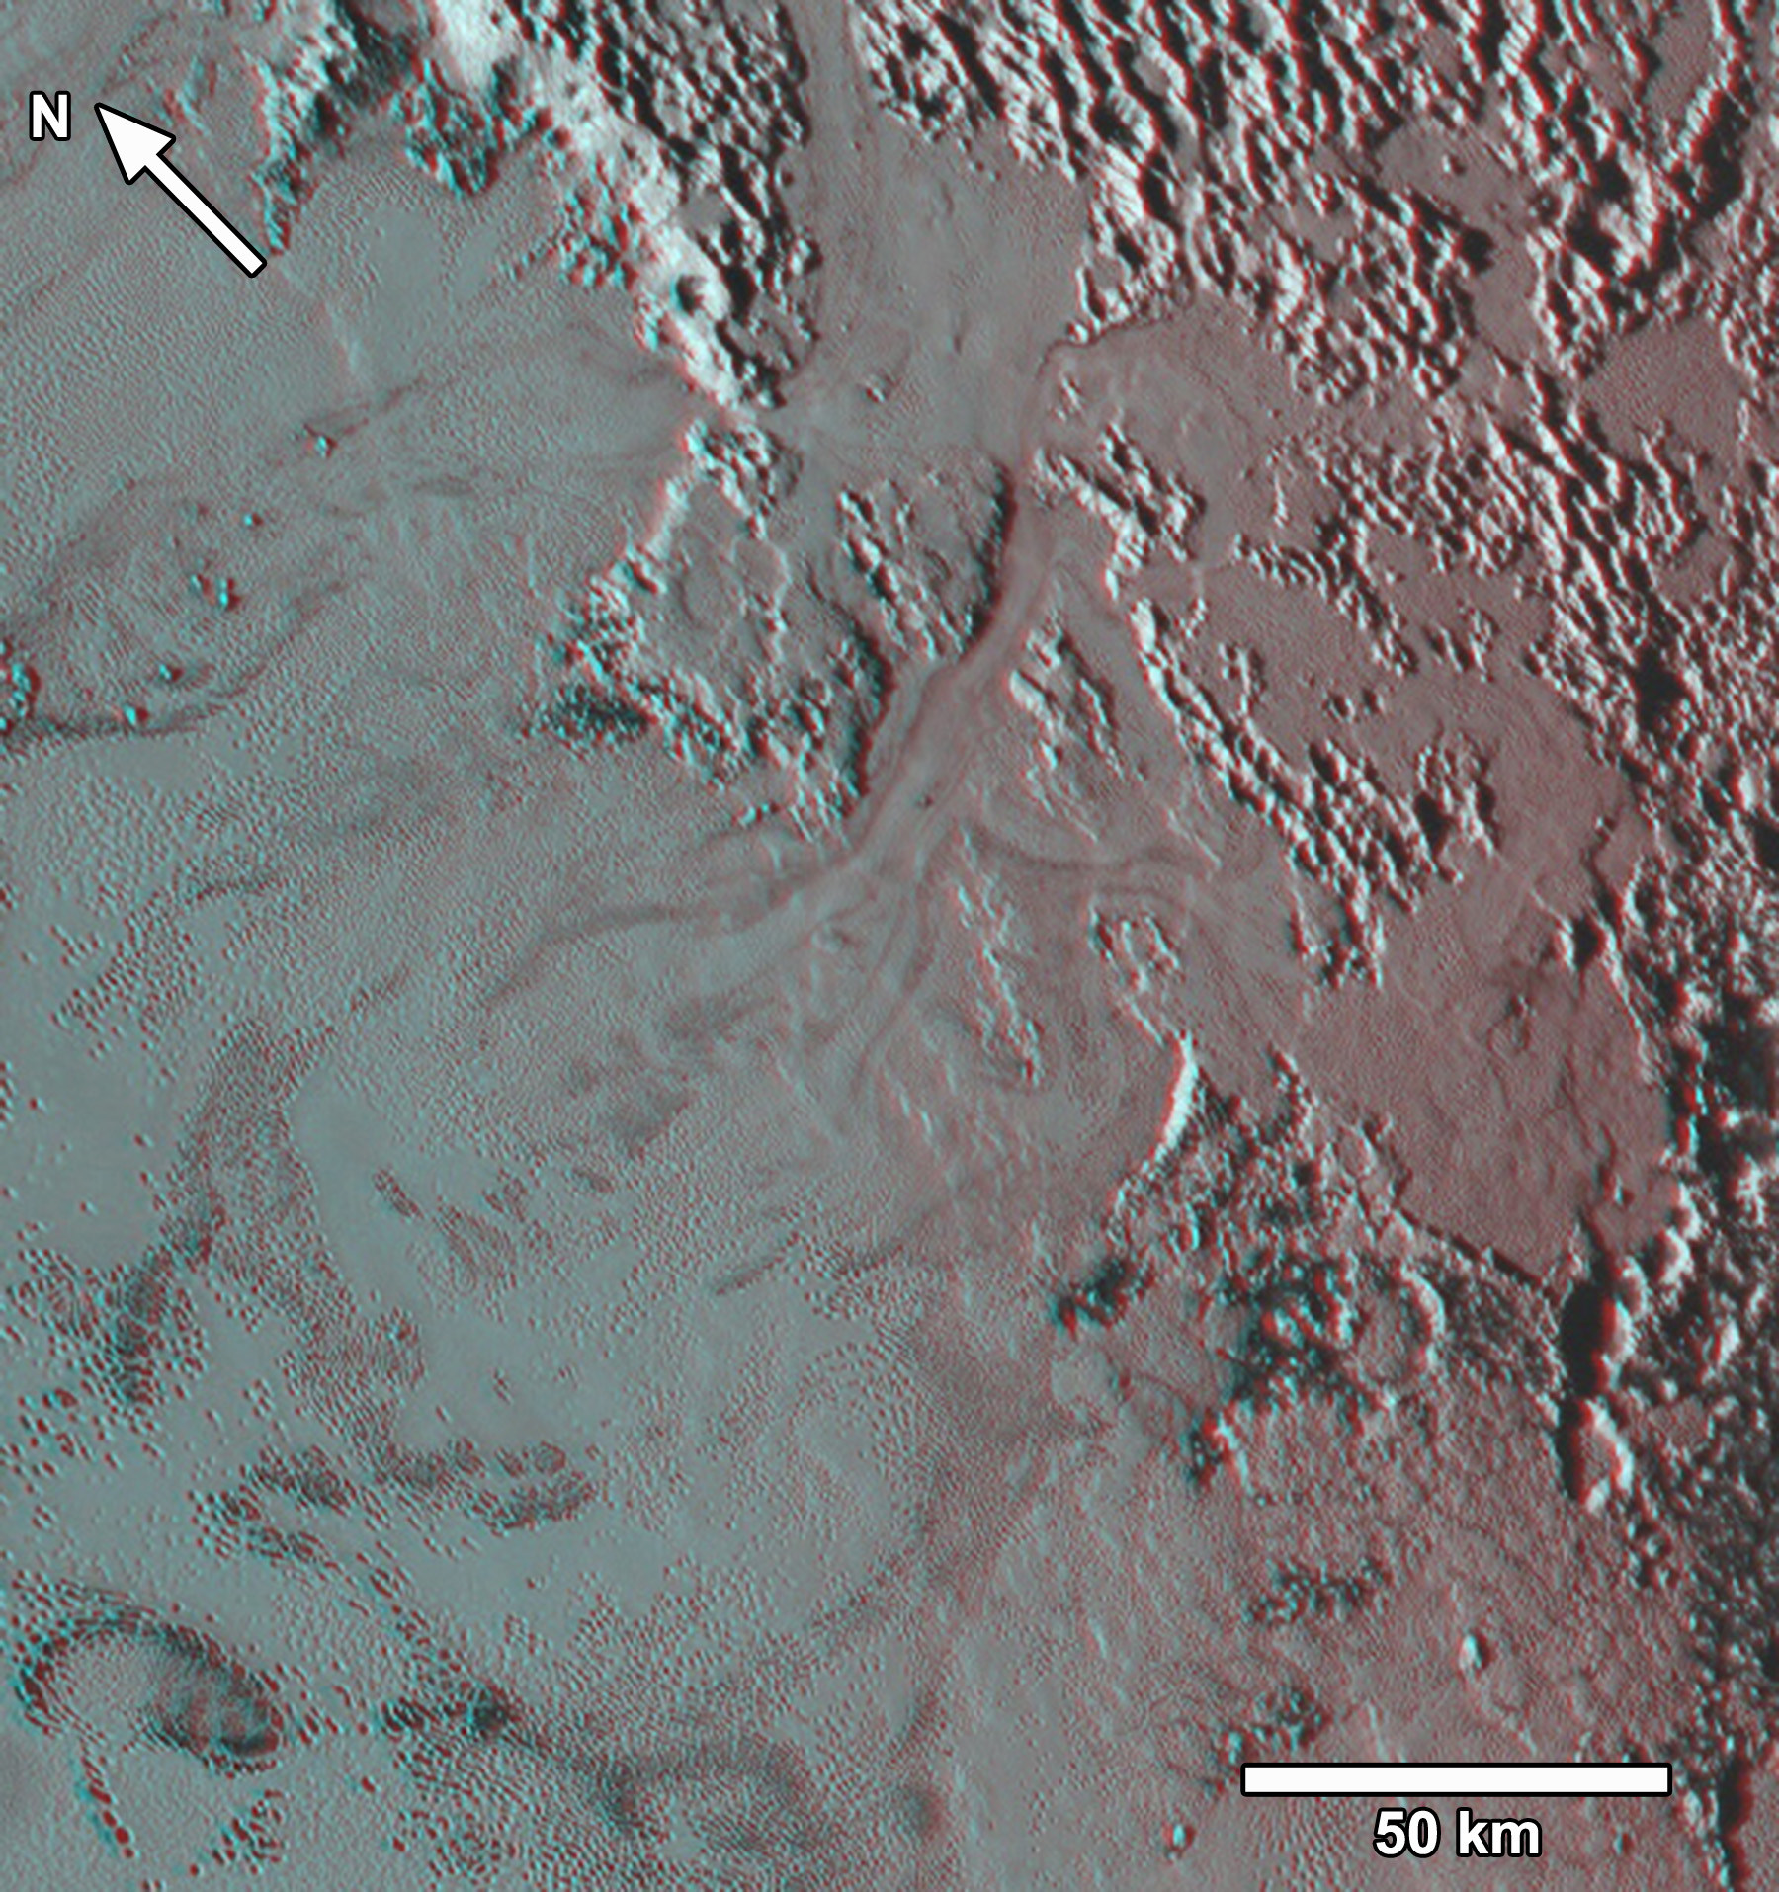
Fig. S1. Anaglyph stereo image of the region shown in Fig. 2. Note that this and other anaglyph images are rotated to provide optimal stereo resolution. Anaglyph from PELR_P_LORRI_STEREO_MOSAIC and PEMV_01_P_MVIC_LORRI_CA.
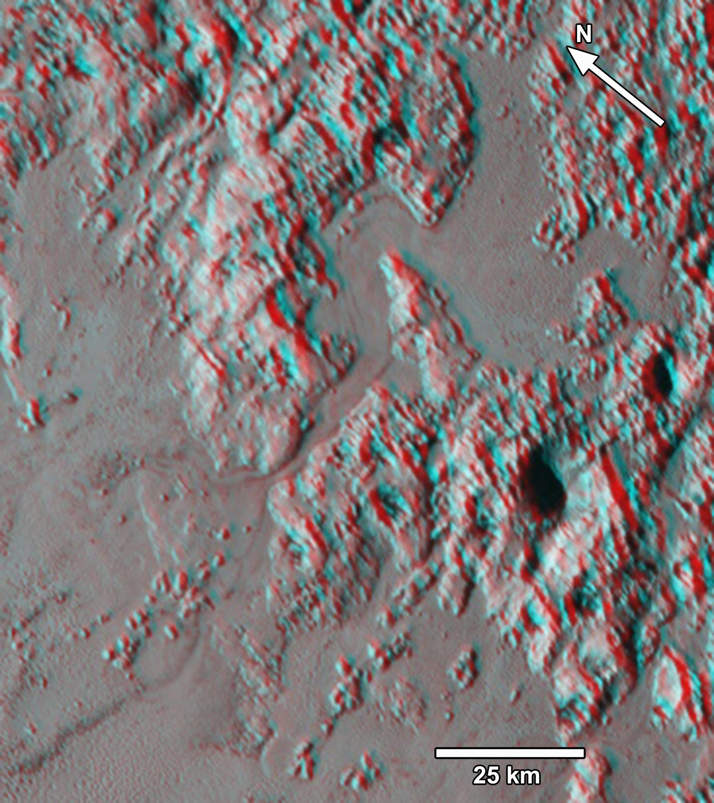
Fig S2. Anaglyph stereo image of glacial flow through a 2 km-wide trough into SP. Note flow lines and fan-like deposit of ice on SP just beyond the trough termination. Blocks of about 1 km diameter protruding above SP ices may be broken-off parts of the pitted uplands ice-rafted through the trough onto SP. Anaglyph from PELR_P_LORRI_STEREO_MOSAIC and PEMV_01_P_MVIC_LORRI_CA.
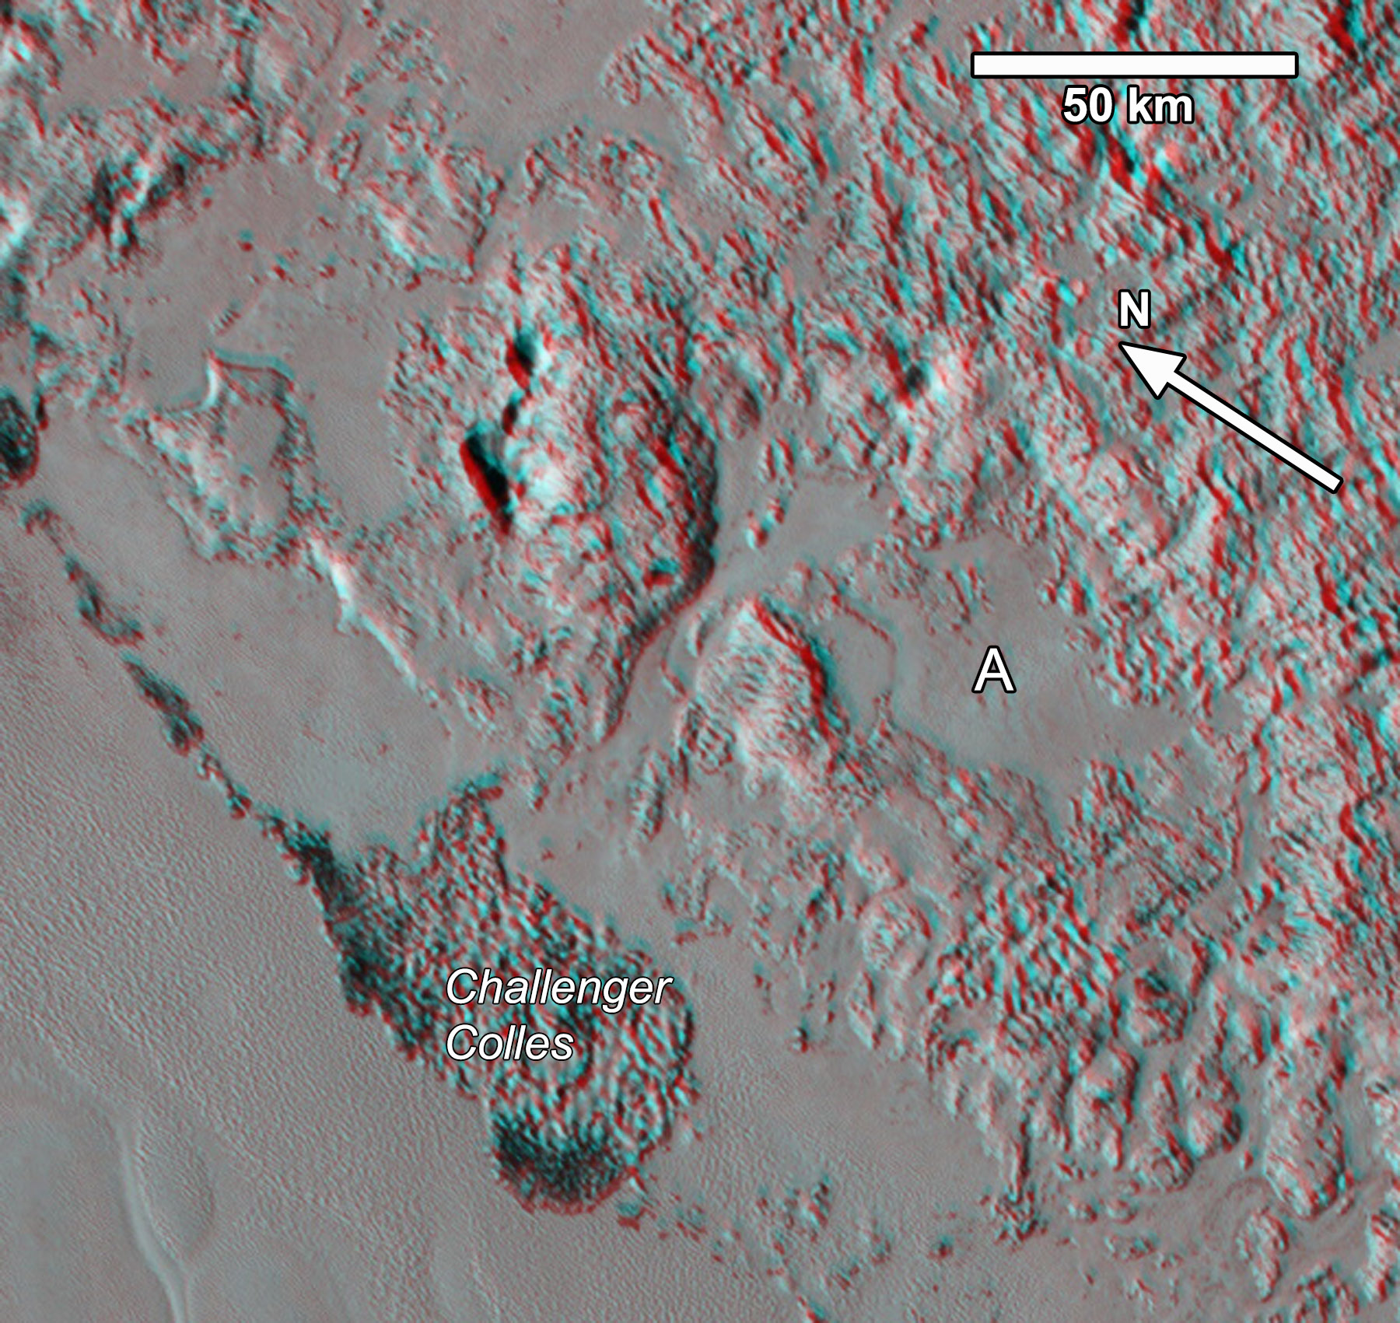
Fig. S3. Anaglyph image of glacial flow from N₂-rich upland plains through a 2.5 to 6 km wide trough onto SP. The line and large collection of blocks on SP (Challenger Colles) are interpreted to be detached pitted uplands material that has been ice-rafted up to 40 km into SP. The icy flats at the upper left are separated from SP by scarps and may not be actively flowing onto SP at present. Parts of the icy flat at “A” are likewise largely isolated from the trough and may not be presently active. Anaglyph from PELR_P_LORRI_STEREO_MOSAIC and PEMV_01_P_MVIC_LORRI_CA.
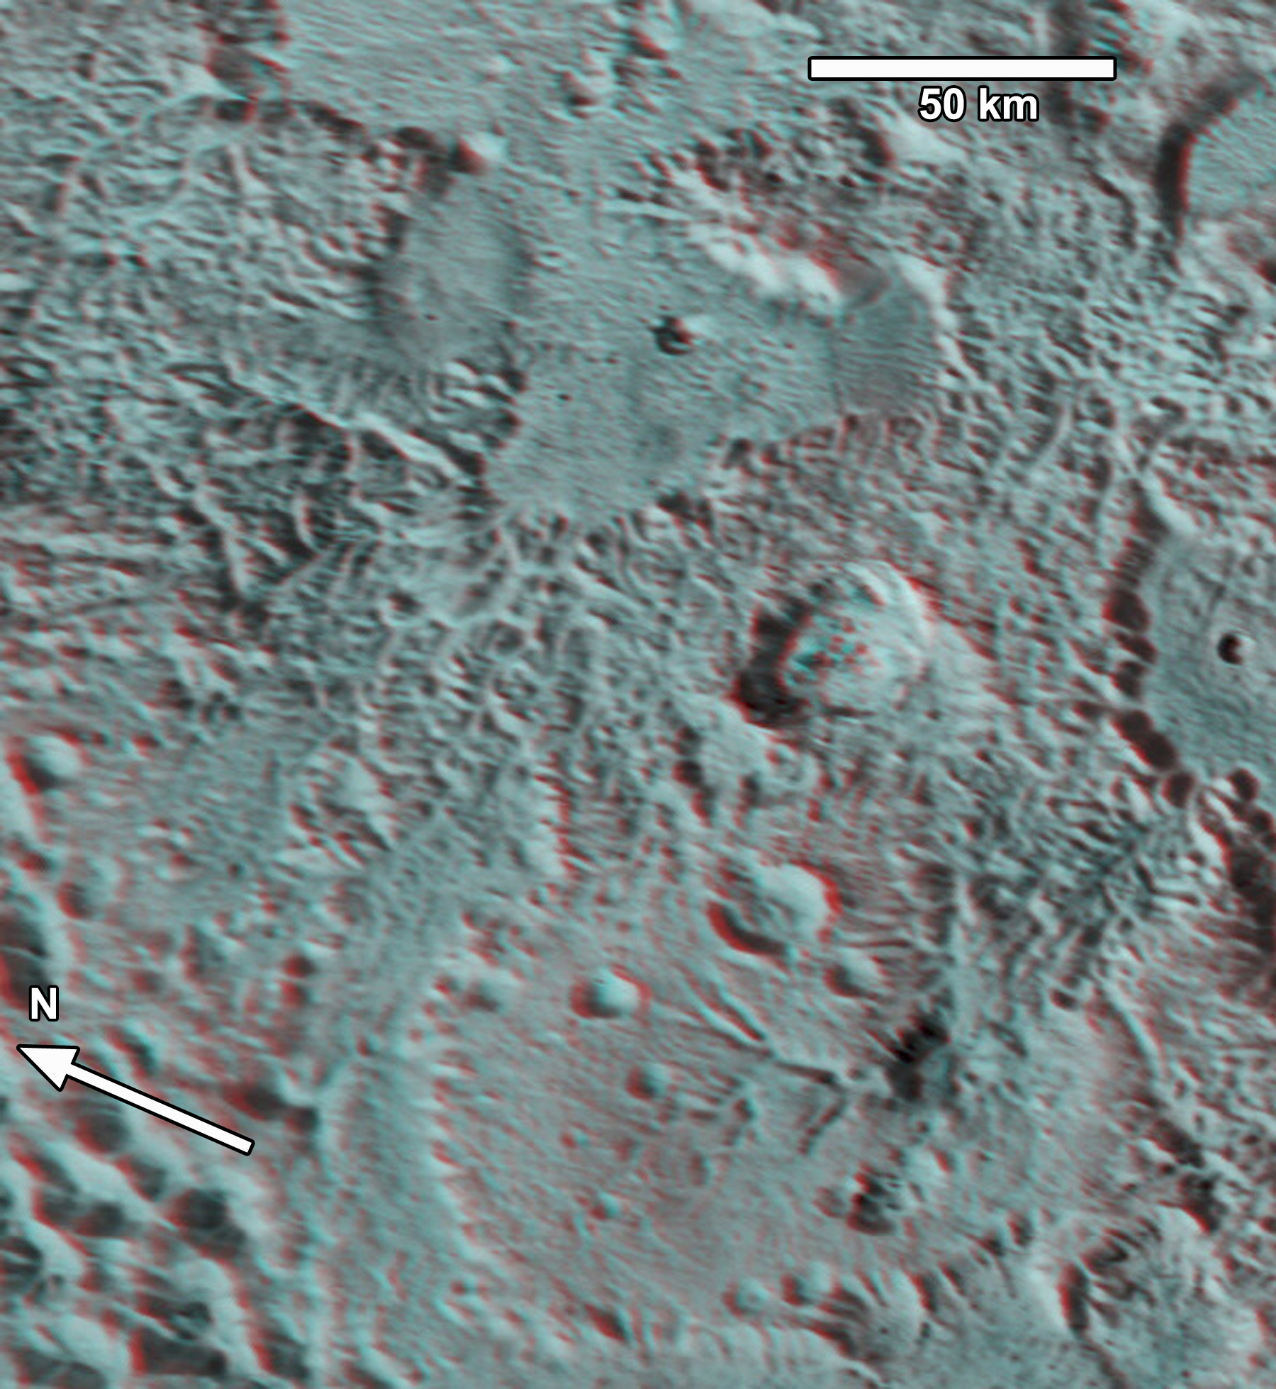
Fig S4. Stereo anaglyph image of valley networks in a portion of the region shown in Fig. 10. Anaglyph of MVIC images PEMV_01_P_MPAN1 and PEMV_01_P_MVIC_LORRI_CA.
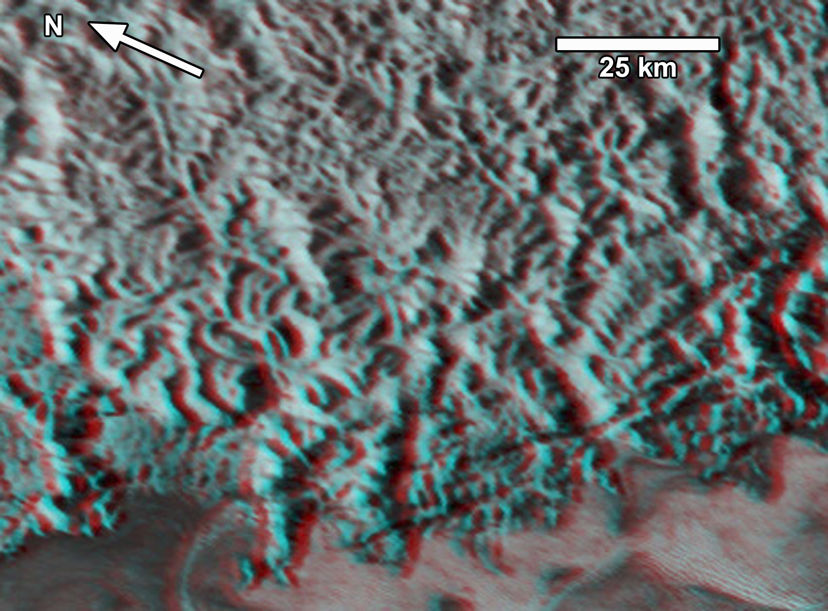
Fig S5. Stereo anaglyph image of mountainous style of valley dissection. Sputnik Planum ices along lower border. Image centered at about 189.9E, 46.2N. Image from LORRI PELR_P_LORRI_STEREO_MOSAIC and MVIC PEMV_01_MVIC_LORRI_CA. See Fig. 1 for location.
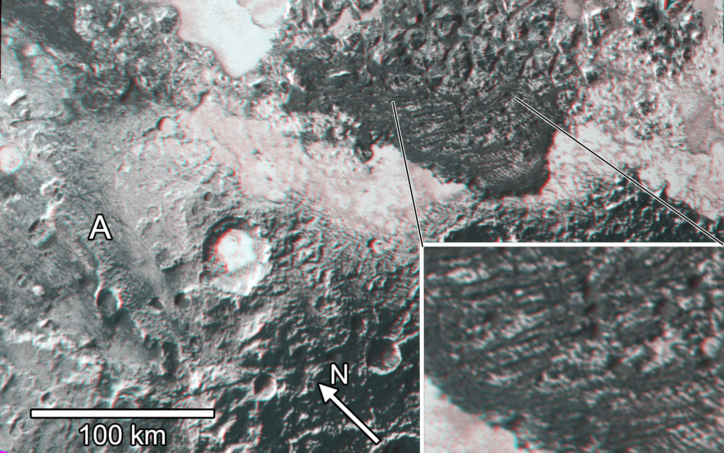
Fig. S6. Anaglyph image of mountainous blocks and densely cratered uplands on western boundary of SP. In the inset dark bands appear to be superimposed on a plateau of water ice blocky mountains, and are tentatively interpreted as recessional moraines of tholin-rich materials deposited during retreat of glaciers formerly covering the region. Elevation range is about 6 km. Note tilted crustal block at “A”. Anaglyph from overlay of 260 m/pixel LORRI PELR_P_LEISA_HIRES and 400 m/pixel LORRI PELR_P_LORRI_STEREO_MOSAIC. See Fig. 17 for location.

