Names for Pluto’s Two Small Moons:
Nyx (S/2005 P 2) and Hydra (S/2005 P 1):

Submitted to the IAU by the S/2005 P 1 and S/2005 P2 Discovery Team

Alan Stern, Hal Weaver, Max Mutchler, Andrew Steffl
Bill Merline, John Spencer, Marc Buie, Eliot Young,
and Leslie Young

30 March 2006

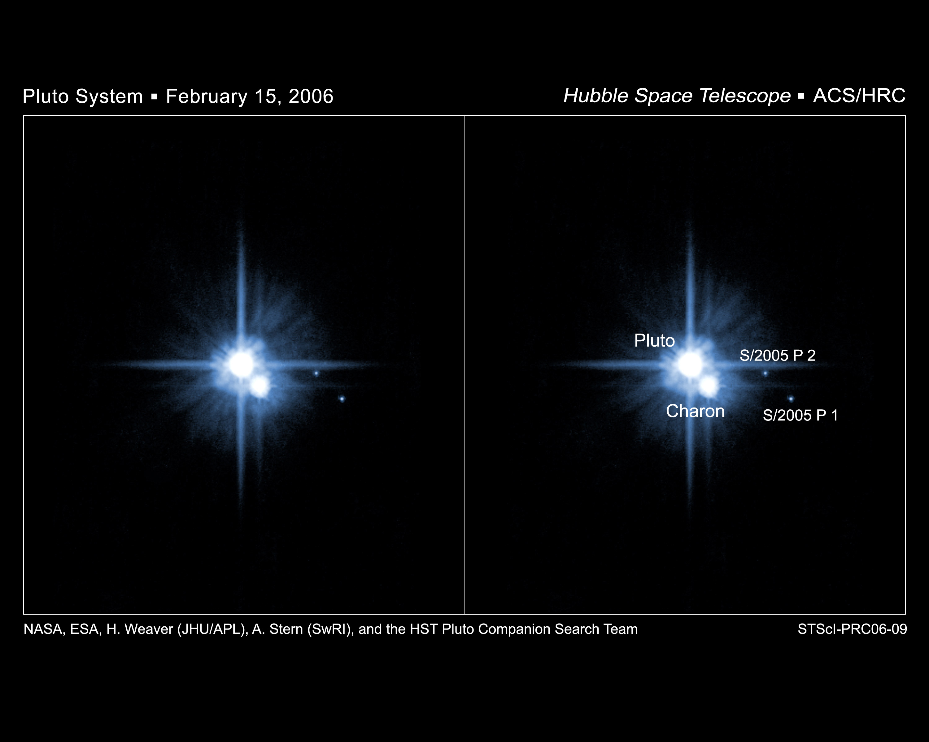

In mid-2005 we used the Hubble Space Telescope (HST) to discover two small satellites of Pluto, both with brightnesses near V~23 (Weaver et al., IAUC 8625; Weaver et al., 2006, Nature 439, 943–945). These observations were proposed to HST and carried out in support of NASA’s New Horizons Pluto Kuiper Belt mission.

With preliminary orbits derived from these observations, the satellites were provisionally named S/2005 P 1 (for the brighter, outer small satellite) and S/2005 P 2 (for the fainter, inner small satellite); see the figure just below for reference.

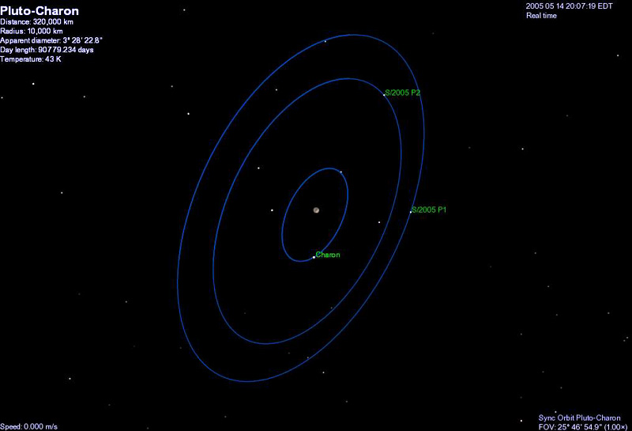

Subsequent HST observations (Mutchler et al., 2006, IAUC 8676; Stern et al., 2006, IAUC8686), as well as archival HST images obtained in 2003 (Buie et al., 2006, AJ, submitted), have confirmed the presence of these satellites and improved on the preliminary orbits for them. These circular, near resonant orbits are in the same plane as Charon, but somewhat more distant from Pluto, providing strong evidence (Stern et al., 2006, Nature, 439, 945-947) for a common origin of all three satellites and new evidence supporting the giant impact onto Pluto that has long been suspected to be the event that precipitated the formation of Charon. Careful searches of the HST data we obtained for additional satellites in the Pluto system have yielded no additional detections beyond S/2005 P 1 and S/2005 P 2; in particular, we obtained quite faint constraints (V~27) farther from Pluto than P 1 (Steffl et al. 2006, AJ, submitted). This of course indicates that S/2005 P 1 is plausibly the outermost moon of Pluto at all, or at least the outermost moon of any size.

As the discoverers of S/2005 P 1 and S/2005 P 2, we have considered various naming possibilities for them and selected the following: For S/2005 P 2, the inner small satellite, we propose Nyx. S/2005 P 1, the outer small satellite, we propose Hydra.

In mythology, Nyx is the goddess of darkness and the night, a very appropriate name for a satellite orbiting Pluto—the god of the underworld. Nyx is also the mother of Charon, which is also appropriate given the giant impact formation paradigm for the formation for Pluto’s three satellites, indicates Charon was born of the material from which Nyx is constructed. No existing planetary satellite bears the name Nyx.

Hydra is the terrifying monster with the body of a serpent with nine heads. This is a particularly appropriate name for the outermost moon of the Pluto system, the ninth planet.

Just as Pluto’s name honored Percival Lowell (by starting with the letters PL) who motivated the search that led to its discovery, Nyx and Hydra can be thought of as honoring the motivation for our search for new satellites, the New Horizons mission to Pluto (by starting with the letters NH). Additionally, we are cognizant that the first letter of Hydra also honors the Hubble Space Telescope (HST), which is the telescope used to discover the satellites.

Finally, we note that the proposed names for the new satellites follow the convention of using names from Greek mythology for the satellites of planets, whose names are chosen from Roman mythology (i.e., Pluto is Roman while its satellites Charon, Nyx, and Hydra are all Greek).

