CRC comments 7/28/04

Discovery that secondary craters dominate Europa’s small crater population
Edward B. Bierhaus*‡, Clark R. Chapman†, William J. Merline†
* Lockheed Martin, Space Exploration Systems, MS S8110, PO Box 179, Denver, CO 80201, USA
†Southwest Research Institute, 1050 Walnut Street, Suite 400, Boulder CO 80302, USA
‡ Previously at University of Colorado at Boulder and Southwest Research Institute, Boulder CO
For several decades, most planetary researchers have regarded the impact crater populations on solid-surfaced planets as predominantly reflecting the direct (“primary”) impacts of asteroids and comets¹. Fundamental inferences, such as the relative and absolute ages of geological units on these planets, have been based on this paradigm². Our new studies of the comparatively sparse crater population on the surface of Jupiter’s icy moon Europa suggest that this assumption is wrong. We find that secondary craters (craters formed by material ejected from Europa’s few large primary impact craters) comprise at least ninety-five percent of the small (less than one km diameter) craters on Europa. There are several profound consequences of this result, which include: (a) there are few small comets (less than [one hundred?] meters diameter) passing through the Jovian system; and (b) large primary impacts into a solid surface (e.g. ice, rock) produce far more secondaries than traditionally believed, implying the small crater populations on the Moon, Mars, and other large bodies with solid surfaces must be significantly contaminated by secondaries.

Introduction
The production and distribution of secondary craters has been poorly understood and controversial, especially concerning the number produced by a single primary impact crater and hence the proportion of smaller craters that are secondaries^{3,4}. Fragments that make distant secondaries are ejected, and thus impact, at higher velocities than well studied close-in secondaries, making them appear quite similar to small, primary impact craters; the greater distances between a primary and its far-flung secondaries also obscure their spatial association. In addition, densely cratered surfaces such as the Moon have overlapping fields of secondary craters and a high (even saturated), average small crater density, so distinguishing secondaries from primaries, associating secondary clusters with particular primaries, or even identifying clusters at all, becomes difficult.
Secondary craters are problematic if they “contaminate” or even dominate the primary cratering record, i.e. if a researcher designates a large population of secondary craters as primary craters, then any derived values (surface ages or characteristics of the impacting population size distribution) will be severely mistaken. Accurately identifying secondary craters and removing their contribution from the primary crater distributions would dramatically improve our confidence in models for surface ages and impactor fluxes.
Though Europa was the least-well imaged of Jupiter’s Galilean satellites by the Voyager spacecraft, there was sufficient coverage to indicate that Europa had very few large craters relative to Ganymede and Callisto [ref chap in Satellites book, Squyres?]. Early low-resolution views from Galileo confirmed this observation⁵. The first high-resolution Galileo images, however, revealed a different style of cratering at small diameters (tens to a few hundred meters). Although still not like the Moon or the heavily cratered regions of Mars, every region seen at high-resolution on Europa displayed numerous small craters. Equally striking, these craters were not spatially random, but instead appeared in clumps and clusters, suggesting that they were secondaries rather than primary craters⁶. Here we show that the vast majority of Europa’s small craters, at least 95%, are secondary craters.
Data
We analyzed those Galileo spacecraft images of Europa with low data compression, low sun angle, and non-oblique viewing geometries. Three categories of images were measured: (1) high-resolution (scale < 100 m/pixel) images, which sample a wide range of latitude, longitude, and terrain types. (2) Images centered on large impact structures. Our measurements include regions surrounding two large impact craters: Pwyll (a 26 km crater) and Tyre (a roughly 44 km crater), providing information on near-field secondary crater characteristics. (3) Medium-resolution (scale 100-300 m/pix) mosaics. Although the poorer-resolution prohibited identifying craters smaller than a half a kilometer diameter, the increased surface area allowed more robust statistics for the craters with diameters (1-2 km) that likely are near the transition between small primaries and the very largest secondaries.
Results
1. Europa has many small craters; these craters have “steep” size distributions. Contrary to the general perception of Europa as a lightly cratered object, Europa has many small craters. The Voyager-era refrain “Europa has few craters” should be revised to “Europa has few large craters”. The small ones exist in hordes. One of us (E.B.B.) measured 17,000+ craters in the high-resolution mosaics (scales <60 m/pixel), which cover only 0.2% of Europa's surface (plus 10,000 more secondaries surrounding the large craters Tyre and Pwyll). The small, far-field craters demonstrate two characteristics regardless of location on Europa: (1) many to most of the craters are in spatial clusters, and (2) most of the crater size-distributions have “steep” slopes, which means that they have a differential power-law size index of b<-4. (The differential size distribution follows the form dN = k D^{b} dD, where dN is the number of craters in diameter range dD, and k and b are constants. We used a ² non-linear fit to determine k and b.)
2. The small craters are spatially very clustered. To remove the strongly clustered craters as a preliminary estimate of the random background, and to identify specific clusters, we developed a novel technique that combines the single-linkage⁷ hierarchical clustering algorithm, Monte Carlo methods, and a clustering parameter κ. This technique divided the crater population into probabilities P of non-randomness, where a cluster with P >2σ indicates that the cluster is non-random with significance > 2σ. Among nine high-resolution mosaics, the minimum, median, and maximum number of craters strongly clustered at P > 2σ is 35%, 71%, and 80%, respectively.
3. Most of the weakly-clustered and unclustered craters are also secondaries; the actual percentage of true primaries may be only a few percent or less. We found that secondary craters consist of more than just the P > 2σ clustered craters. The shapes of the size-distributions for the less clustered (0.5 < P  2σ) and unclustered (spatially random) craters follow the shapes of the size-distributions for the strongly clustered craters on a mosaic-by-mosaic basis. Had the unclustered populations converged to a uniform distribution, one might conclude that the unclustered craters are the pure, uncontaminated primary crater distribution. That their size-distribution shapes vary regionally, mimicking the regional variations of the strongly clustered craters, suggests that many to most of the unclustered craters are also secondaries. [IT MIGHT NOT BE INTUITIVELY CLEAR WHY THE EXPONENT OF THE SIZE DISTRIBUTION WOULD BE RELEVANT. MAYBE ADD A SENTENCE NEAR HERE LIKE: Size distribution exponents reflect the physical processes of fragmentation and might be expected to vary somewhat for different cratering impacts, unlike the continuing, quasi-equilibrium comminution processes that affect small, interplanetary, primary comets and asteroids. Thus the similarities of the less- or un-clustered craters sizes suggest that they are related to their more tightly clustered siblings.] In addition, the size-distribution shape for the unclustered craters diverges significantly from the shape of the known primary craters for diameter ranges in which the two size-distributions overlap – the primary population⁸ has b > -2, while the “random” small crater populations have slope indices of b < -3. Furthermore, some crater populations that are spatially correlated with crater rays – and thus must consist of nearly 100% secondaries – have lower [LOWER THAN WHAT?] percentages of clustered craters. Therefore, the unclustered craters represent a very strong upper limit on the percentage of small craters that are primaries; the median percentage of spatially random craters is 10%. A better (but still conservative) estimate of the primary crater population is that they consist of only half the unclustered craters, or only 5%.
Implications
There are (at least) three significant implications from our discovery that the bulk of Europa's small crater population is comprised of [IS THIS PROPER USAGE; I AM ALWAYS CONFUSED: MAYBE THIS SHOULD BE “is composed of” or “comprises”] secondary craters. (1) Using [FOR EUROPA, OR HAVE YOU DEVELOPED THE ICE/ROCK EQUIVALENCE ARGUMENT THAT PERMITS THIS TO BE GENERALIZED TO OTHER BODIES? i infer from what is below that you should restrict this paragraph to Europa] the more numerous, and thus statistically more significant, small craters to derive surface ages of small geological units is now suspect. Far-flung secondaries from a single, distant primary crater can dominate a local crater population⁹, so a high-density population doesn't necessarily reflect a greater integrated exposure time; it could instead result from a single, possibly recent, exposure to a cluster of ejecta. (2) The Jovian system's primary impacting population, which are [is?] dynamically understood to be mostly comets¹⁰, is deficient (compared with the size distributions of asteroids, or of larger comets) in objects smaller than ___ m diameter. Because many of the Jupiter-family comets come from the Kuiper belt¹⁰, the Kuiper belt may have a shallow size-distribution at small sizes. (3) Ejecta production that makes secondary craters is staggeringly efficient. There are very few large primary craters on Europa (less than 40 are currently known > 10 km diameter globally), yet our identification of tens of thousands of secondaries in only 0.2% of Europa's surface imaged at high resolution by Galileo implies that the few large primaries made at least 10 million secondaries (larger than ____). Although mechanically ice and rock behave somewhat differently during the crater excavation process, very cold ice like that on Europa behaves similarly to rock, so impacts into rocky terrain should also produce multitudes of secondary craters. Thus secondary craters significantly contaminate the small-crater record of the inner Solar System. Any attempt to derive surface ages or traits of impacting populations (i.e. of near-Earth objects at diameters below what's robustly sampled in telescopic surveys) based on lunar or martian small-crater curves will suffer a significant bias due to the contribution from secondaries. McEwen¹¹ suggests that this is true for Mars. We calculate that the steep branch of the lunar crater population could be substantially or fully accounted for by secondary cratering from large, post-mare, primary impact craters, if the secondary cratering efficiency we have found for Europa applies to the Moon.

References
1. XXX, eds. Basaltic Volcanism Study Project, Chapter 8 (1981).
2. Shoemaker, E.M., Hackman, R.J. & Eggleton, R.E. Interplanetary correlation of geologic time. Adv. in Astronaut. Sci. 8, 70-89 (1963).
3. Shoemaker, E.M. Ballistics of the Copernican ray system. Proceedings of the Lunar and Planetary Colloqium 2, No. 2 (1960).
4. Reference suggesting few secondaries
5. Reference for early Galileo Europa cratering results (Chapman/Merline abstract)
6. Bierhaus, E.B., Chapman, C.R. & Merline, W.J. On the Clustering of Europa's Small Craters. LPSC XXXII, #1967 (2001).
7. Duda, R.O. & Hart, P.E. Pattern Classification and Scene Analysis, John Wiley and Sons, New York (1973).
8. Zahnle, K., Schenk, P., Levison, H., & Dones, L. Cratering rates in the outer Solar System. Icarus 163, 263-289 (2003).
9. Bierhaus, E.B., Chapman, C.R., Merline, W.J., Brooks, S.M. & Asphaug, E. Pwyll Secondaries and Other Small Craters on Europa. Icarus 153, 264-276 (2001).
10. Levison, H.F. & Duncan, M.J. From the Kuiper Belt to Jupiter-family comets: the spatial distribution of ecliptic comets. Icarus, 127, 13-32 (1997).
11. McEwen ref, either his Mars conference abstract or his Icarus paper

Acknowledgements
[PROBABLY SHOULD ACKNOWLEDGE, HOWEVER BELATEDLY, OUR JSDAP FUNDING AND THE GALILEO PROJECT.] How about something to the effect of:
NASA’s Galileo and JSDAP [WRITE OUT] programs funded the research reported here.
Figure Legends
FIGURE 1. (a) The ~ 43 m/pixel E17LIBLIN01 mosaic. North is up, and the sun is from the right. There are about 1000 craters identified in this mosaic. (b) Plot that identifies the crater centre locations within the mosaic, colour-coded to the degree of clustering: red is P > 3σ, yellow is 2σ < P  3σ, green is 1σ < P  2σ, blue is 0.5 < P  1σ, black is spatially random.
FIGURE 2. Plot demonstrating the size-distributions for strongly clustered, less clustered, and spatially random crater populations. The format is essentially a histogram: the number of craters within a diameter range. The error bars only reflect the statistical N^{1/2} counting error. The spatially random data are generally less steep than the clustered data, but do not converge to a uniform distribution. Instead, they follow the trends of the strongly clustered data, indicating that secondaries comprise much of the spatially random data as well.
[IS THERE A MORE EFFICIENT WAY OF COMBINING THESE DIAGRAMS?]

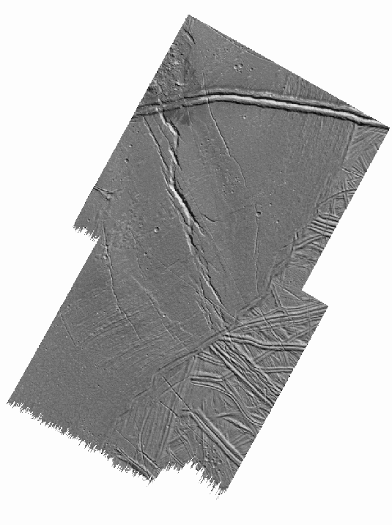
Figure 1a
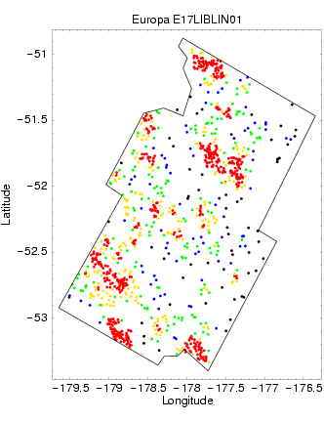
Figure 1b

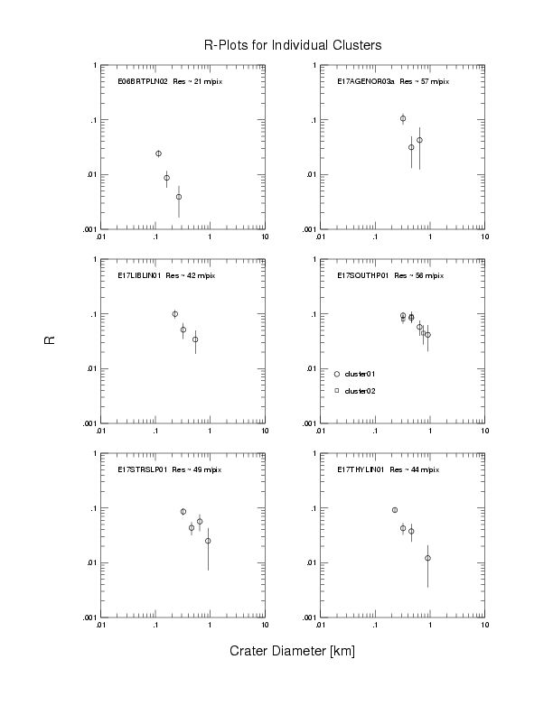
Figure 2

