Commercial Jet Training in Preparation for Suborbital Spaceflights: Public Service Information

Constantine Tsang, Cindy Conrad, Dan Durda, Cathy Olkin, Alan Stern
Southwest Research Institute, Department of Space Studies, Boulder, Colorado, USA

Abstract

Commercial suborbital vehicles will allow the next generation of scientists, engineers, technologists and educators to fly and operate experiments in the new environment of suborbital space. Training to conduct experiments in the most efficient and excellent manner possible requires some training to prepare the individual for the rigors of launch and re-entry. The cost of such training however, should only be a small percentage relative to the cost of the suborbital mission and experiment. Here, we provide information and details for the suborbital community concerning jet training by current commercial flight providers, their capabilities and relative costs, which mimics the realistic flight environment of upcoming suborbital spaceflights.

Merits of Training

An individual who will be conducting technical or scientific work on a suborbital spaceflight should spend a prudent quantity of time training for the precious minutes in the microgravity suborbital environment. This usually includes, but not exclusively, centrifuge and hypoxia training (e.g.: The NASTAR Center) and a microgravity flight (e.g.: Zero-G Corporation). This exposes the individual to typical high-G and µ-G forces in a controlled and safe environment. A further step in this training might be flights on high performance jet aircraft. This helps combine both the forces of hyper-G and µ-G in a real world ‘dirty’ setting, that may include wearing flight gear (oxygen mask, G-suit, pressure suit), putting the flight participant in the most realistic environment possible. It may also include the potential to operate simple experiments and test operating procedures. As a result, a fast jet flight could be considered the last training step before executing a suborbital spaceflight.

Commercial Flight Providers

A surprisingly large number of commercial flight providers of ex-military jet aircraft are currently in operation within the United States alone, and are open to purchase of flights. They include military jet trainers such as the ex-Soviet block L-29 Delfin and L-39 Albatross, Korean-era fighters such as the MiG-15 and P-80/T-33 Shooting Star, Vietnam-era fighters MiG-21 Fishbed, MiG-23 Flogger, A-4 Skyhawk, F-4 Phantom and the F-104 Starfighter. “Modern day” aircraft such as the Dassault Alpha Jet, one of which is currently being used by the NASA Ames AJAX atmospheric trace gas experiment, are also available to commercial vendors. Most of these commercial companies operate these aircraft either as dis-similar aggressors for the United States military, or for historical flight experience flights, and as a result provide excellent training platforms.

Conclusions

Capabilities of traditional training jet aircraft used by NASA (T-38 Talons) can be readily mimicked by the commercial sector, and leveraged by the suborbital spaceflight community. Our vendor research has highlighted a large number of domestic flight providers, which can benefit the suborbital community’s training requirements, as well as help bolster the sustainability of operating these historically significant but expensive warbirds.

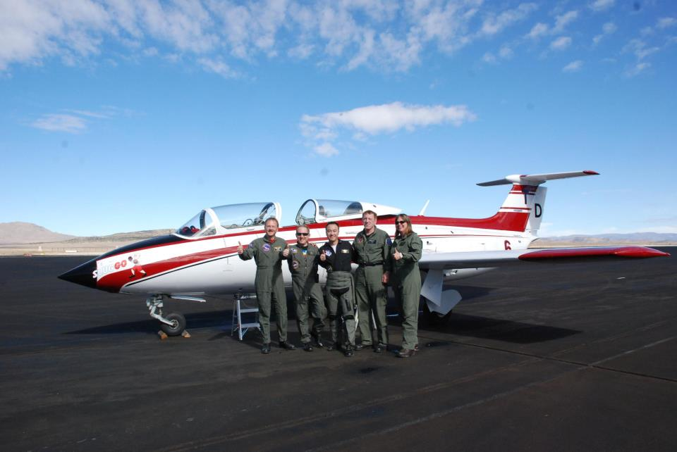
Figure Insert: SwRI suborbital flight crew receiving training in a Reno Air Race Aero L-29 Delfin in 2012. Left to right: Dan Durda, Alan Stern, Con Tsang, Joe Gano (Warbirds of Delaware pilot), Cathy Olkin

