Comment on
"Abrupt and Gradual Extinction Among Late Permian
Land Vertebrates in the Karoo Basin, South Africa"

Clark R. Chapman
Southwest Research Institute
Suite 400, 1050 Walnut St., Boulder CO 80302

11 May 2005

Abstract. Vertical distributions of nine fossil skulls indicating that a gradual extinction preceded the sudden mass extinction at the Permian-Triassic boundary are, instead, wholly consistent with a sudden event. Statistics of such small numbers show even stronger gradualism where none exists in 3 of 10 random trials.

There is suggestive but inconclusive evidence that the Permian-Triassic (P-T) mass extinction occurred suddenly (1), like the accepted asteroid impact origin for the Cretaceous-Tertiary (K-T) boundary. Ward et al.'s (2) widely publicized study acknowledges some sudden extinctions at the P-T boundary, but argues that some species died out gradually beforehand. They also argue "that at least some species originated" before the boundary. Neither conclusion is supported by their data.

Ward et al. define a zero-level plausibly marking the sudden component. I inquire whether the plotted vertical distributions of fossils plausibly negate a wholly sudden mass extinction. They assigned 126 skulls to 21 taxa, which I refer to numerically from left-to-right in their Fig. 3. The entire case for gradualism rests on at most 16 skulls representing taxa 1-6, especially 9 skulls in taxa 1-3, for which Ward et al. express confidence that extinction occurred below (before) the zero-level. Taxa 4-6 (based on minimal data) are acknowledged as going extinct “at or near” the zero-level. (For taxon 5, although represented by just one skull, Ward et al. inexplicably plot a confidence interval 25m above its height [3].) The data for remaining taxa can be interpreted as follows: 7 and 8 (and possibly 10, represented by just one skull) went extinct at the zero-level; 9, 11, 12, and perhaps 13 passed through but went extinct later; and taxa 14-21 originated above (after) the zero-level (the extinction opened ecological niches, plausibly fostering speciation).

The uppermost skull was ≥10m below the zero-level for taxa 1-3. I take the bottom sampling level to be -60m, based on abundant taxon 7. The 9 skulls are distributed vertically as shown in column 0 of Fig. 1. The case for gradual extinction before the boundary depends solely on a statistically convincing tendency for skulls in these three taxa to be missing as the zero-level is approached. Columns 1-10 show ten random distributions for 9 items between 0 and 60. Plainly, there is no robust case for a gradual extinction. Three of the ten random trials show an even stronger avoidance of the zero-level than the actual data (the data even avoid the -60m level more than 9 of the 10 trials). Thus, the data are consistent with taxa 1-8 and 10 going extinct at the boundary. (Taxon 1, taken alone, is actually indeterminate. Based on just 2 skulls from almost exactly the same height [~-52m], it cannot provide evidence about origination or extinction, though Ward et al. manage to plot an extinction confidence interval at -50m !)

Another Ward et al. conclusion is that "some" species "probably" originated below (before) the zero-level. For these taxa (14-21), no skull came from below the zero-level; the closest is 10m above it. Radiation of new species following a sudden extinction can be refuted only by finding a skull below zero-level. Height distributions above zero predict probable events below zero only if earlier times were unchangeable (3). While a complex history is allowed, data for taxa 14-21 say nothing about whether a dramatic event happened below the lowest skull; any non-randomness could reflect real ecological changes in this locale or sampling biases.

In many sciences, three-sigma confidences are the standard of proof. Anything less than fifty-fifty chance is clearly unproven. "Error-bars" in Ward et al.'s Fig. 3 typically extend beyond the last datum by less than average distances between data. (Actually, these "error-bars" have an arcane, non-intuitive meaning [3]: 20% confidence intervals.) In any "confident" interpretation of when a taxon goes extinct, its error bar should extend beyond the 1-, 2-, or 3-sigma levels. Ward et al.'s Table 1 presents similarly dubious confidence estimates. Their only confidence >0.5 is 0.875 (three significant figures!) for early extinction of taxon 1 -- the one with just 2 skulls, both at the same height. Taxon 1 simply has no probative value concerning gradualness of extinction. Fig. 1 and common sense (no formal statistical tests of just 9 data points are required) clearly do not endorse a gradual component to the extinction.

Indeed, these statistics of fossil skulls from a non-marine, terrestrial environment, may just represent the evolving Karoo ecology and simple migrations of species to other parts of Pangea, rather than extinction. Astronomical evidence is that impact of one or more asteroids or comets larger than the K-T boundary extinctor is statistically likely in the past 0.5 Gyr (4). The Earth can hardly have avoided the inevitable, horrific resulting environmental consequences (5). Thus, absent any countervailing evidence or alternatively sudden, energetic modifier of the ecology, the presumption must favor the inevitable asteroid or comet impacts to explain mass extinctions, unless proven to be false. Ward et al. have not met that standard.

References and Notes

1. D. H. Erwin, S.A. Bowring & J. Yugan 2002. End-Permian mass extinctions: A review. In Catastrophic Events and Mass Extinctions: Impacts and Beyond (ed. C. Koeberl & K.G. MacLeod), Special Paper 356 (U.S. Geological Survey), 363-383.

2. P.D. Ward, J. Botha, R. Buick, M.O. De Kock, D.H. Erwin, G.H. Garrison, J.L. Kirschvink & R. Smith 2005. Abrupt and gradual extinction among late Permian land vertebrates in the Karoo Basin, South Africa. Science 307, 709-714.

3. S.C. Wang & C.R. Marshall 2004. Improved confidence intervals for estimating the position of a mass extinction boundary. Paleobiology 30, 5-18. This paper, and others cited therein, define mathematics for interpreting fossil heights in uniformly sampled stratigraphic sequences. These procedures have been misused by Ward et al. The 20% confidence limits mean that there is an 80% chance that a range extends beyond the plotted “error bar”. One cannot plot such confidence intervals for taxa (like 5 and 10) based on just one fossil, since the formula involves division by (H-1) where H is the number of fossils. The plotting of a 90% confidence interval for the extinction level in Ward et al.’s Fig. 3 cannot be right; the claim is that the calculations are for “the nine taxa,” (presumably those with last occurrences at or below the zero-level, although C values are tabulated for 12 taxa in Table 1, including several that extend well above the zero-level), but only 7 have 2 or more occurrences, required for calculating confidence. And, according to Table 3 of Wang & Marshall, treatment of 7 (or even 9!) taxa requires use of confidence levels appreciably greater than the 20% used. Moreover, Wang & Marshall are clear that their method for estimating an extinction level applies only if all taxa are known to have gone extinct at that horizon; Ward et al.’s belief that ≥3 taxa went extinct “gradually”, beforehand, invalidates that assumption. Actually, many of Wang & Marshall’s simulations graphically show apparent “gradual” extinctions, even though all taxa in their simulations are defined to have gone extinct simultaneously. Application of Wang & Marshall’s method to disproving an hypothesized origination horizon violates the stated assumption that “fossil horizons [must] be distributed independently and uniformly throughout the taxon’s stratigraphic range;” the distribution can hardly extend “uniformly” below the assumed horizon.

4. C.R. Chapman 2002. Impact lethality and risks in today's world: Lessons for interpreting Earth history. In Catastrophic Events and Mass Extinctions: Impacts and Beyond (ed. C. Koeberl & K.G. MacLeod), Special Paper 356 (U.S. Geological Survey), 7-19.

5. O.B. Toon, K. Zahnle, D. Morrison, R.P. Turco & C. Covey 1997. Environmental perturbations caused by the impacts of asteroids and comets. Revs. Geophysics 35, 41-78.

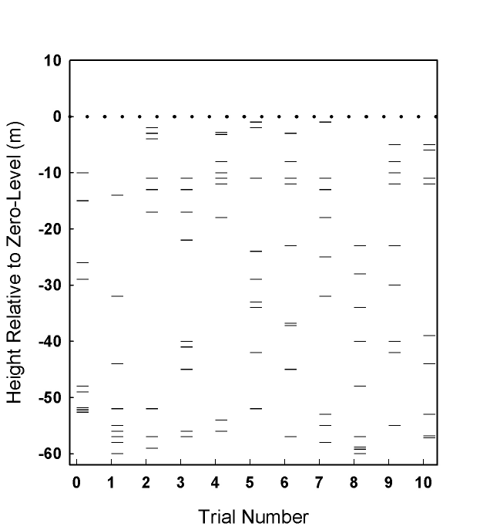

Figure 1. The dotted line represents the zero-level of Ward et al., hypothesized to be the time of an abrupt mass extinction. Trial 0 shows the actual data of Ward et al., the heights of 9 skulls representing the three taxa about which Ward et al. express confidence of extinction well below the zero-level. Trials 1-10 represent random selections of 9 integers between 0 and -60. Trials 1 and 8 show much more dramatic avoidance of the zero-level than do the actual data, but they are as likely to result from random chance as trials 5 and 7, which closely approach the zero-level.

